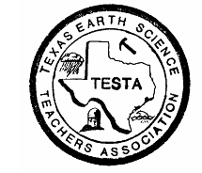 Texas Earth Science Teachers Association

The TESTA

Tailings…

Summer - 2013

## 

## TESTA Presents...

We would like to give a great big thank you to everyone who has volunteered to present a workshop or short course as part of the TESTA Strand at CAST 2013! For the strand, TESTA will have two or three rooms dedicated for earth science hour long workshops, and short courses that are either 3 or 6 hours in length. I am currently aware of at least two 3-hour short courses and seven different workshops proposals submitted. But I have not received the final list yet from STAT but so far the following members will be presenting as part of the TESTA Strand at CAST: Stef Paramoure, Lyle Baie, Julie Pierce, Lale Bilir, Devalyn Rogers, Mary Kay Hemenway, Roger Palmer, Christine Shupla, Gary Kitmacher, Denise Smith, and Don Cooper. If I have missed your name as a presenter, please contact me as soon as possible!

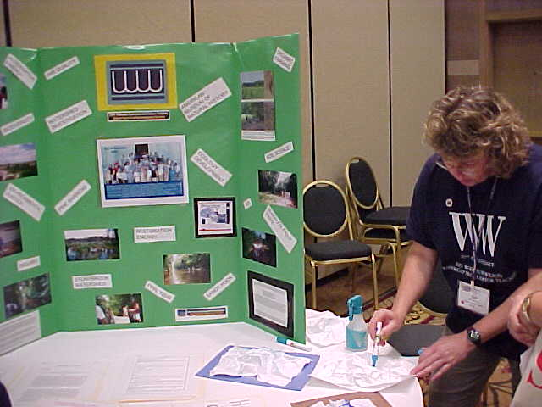

**Share – A – Thon Presenters:**

TESTA would like to extend a great big Thank You to the following people who have agreed to present at the TESTA Share-a-Thon on Saturday morning of CAST 2013. Currently on the presentation list are: Denise Smith, Lale Bilir, Julie Pierce, Wanda Pagonis, Delphinia Denny, Gail Gant, Kathryn Barclay, Theresa Cooke, and Lexy Bienek. We want to have all of our presenters recognized in the CAST program as being a part of the Share-a-Thon. This is a great way to be a presenter without doing a complete workshop session or a short course. It is also great for your PDAS and to promote your school and district. **If you would like to present or I have accidently missed recording your name as a presenter, please let me know as soon as possible.**

**C:\Documents and Settings\kathryn.barclay\Local Settings\Temporary Internet Files\Content.IE5\U22XUUQT\MC900411061[1].wmf**

**Congratulations to Denise Pool – TESTA Teacher of the Year - 2012 – 2013!**

Denise teaches 5th grade science at Lomax Elementary School in the La Port ISD. She has been teaching for only five years but she has been recognized as her school’s Rookie Teacher of the Year and was runner-up for Teacher of the Year for the 2011 – 12 school year. Denise also attended the 2011 Smithsonian Science Education Academy for Teaching Earth’s History & Global Change in addition to attending the *Rice Elementary Model Science Lab School* to receive intensive training in teaching Science through hands on learning with college readiness in mind for the 2010-2011 school year. In her application, Denise summarized her philosophy of teacher as follows: *“My philosophy as an educator is to present all the science I can in such a way that when our time ends each school year, every student will know that they are scientists and an active part, important part, of the world around them.”*

Every year at CAST, we honor our TESTA Teacher of the Year. Requirements for Teacher of the Year are as follows:

* Be a member of TESTA
* Teach earth science units and/or classes in a Texas public or private school for a minimum of at least 3 years.
* Apply by submitting the following items – Resume and a Letter of Recommendation from a colleague or administrator, and a one to two page essay on your philosophy of teaching.
* Applications should be submitted electronically to – [texasearthscienceteachers@aol.com](mailto:texasearthscienceteachers@aol.com)

**Denise will be recognized during the TESTA luncheon at CAST 2013. She will receive an engraved plaque, $300.00 award check, and complementary tickets to the luncheon. Please join us in congratulating Denise Pool as the TESTA Teacher of the Year!**

**Apply for a TESTA Grant for the 2013 – 2014 School Year!**

Do you have a great idea for implementing an Earth Science based lesson or some new activities into your curriculum but need some money to bring it to life? If so, you need to apply for up to a $300.00 grant from TESTA!

**Criteria for judging and receiving the grant:**

* Be a current TESTA member.
* Financial plan to purchase durable items that can be used multiple times and/or cross curriculum topics. Consumable items and student travel should be limited or can be funded via another source.
* Impact as many students as possible via classroom lessons and/or science club activities.
* Proposal promotes and enhances the understanding of earth science and its impact on our community and society.
* Agreement to submit a follow up report of the “grant in action” to TESTA for our publications and archives.
* Funds cannot be used for teacher travel and professional development.

**To apply:**

1. Provide a description of your plan and how it will be implemented.
2. Provide a detailed budget of what you need to implement the plan.
3. Provide a letter of support for your plan from a school administrator. This can be in email format!
4. Submit application information to – [texasearthscienceteachers@aol.com](mailto:texasearthscienceteachers@aol.com)

**C:\Documents and Settings\kathryn.barclay\Local Settings\Temporary Internet Files\Content.IE5\M31U45Y7\MC900297729[1].wmf**

**Got Travel Plans?**

As you go about your well deserved summer vacation, please remember the TESTA Rock Raffle at CAST and bring home a few rocks, fossils, sand, sea shells, and minerals to donate! Just pop some of your findings into a zip-lock and include a note of where it was found or collected and then bring it to CAST with you. This is a great way to support TESTA’s only fundraiser and help teachers add to their collection of items for their classroom.

**Great books for hunting gemstones and minerals!**

The ***American Traveler Series*** publications by Renaissance House. These books contain extremely detailed maps and directions of places that you can visit to look for and collect rocks, minerals and fossils that are found in that area. The instructions tell you exactly where to look and what tools or items that you may need to help you successfully hunt for treasures!

The books are $6.95 each and Field Guides are $1.75 each.

All books can be ordered from the following website –

<http://www.americantravelerpress.com/books.php?Category=1040>

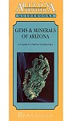**Gems and Minerals of Arizona**

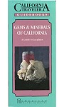**Gems and Minerals of California**

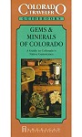**Gems and Minerals of Colorado**

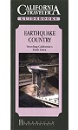

**California – Earthquake Country**

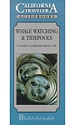

**California – Whale Watching and Tidepools**

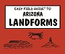

**Easy Field Guide to Arizona Landforms**

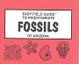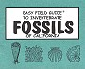

**Easy Field Guides to Invertebrates Fossils of California and Arizona**

Since Arizona and Colorado are way out of the way for us Texans that seldom get beyond the borders of Texas here is some ideas:

**BEG publications**

<http://begstore.beg.utexas.edu/store/search?tag=guidebooks>

**Roadside geology of Texas and other states**

<http://geology.com/store/roadside-geology-texas.shtml>

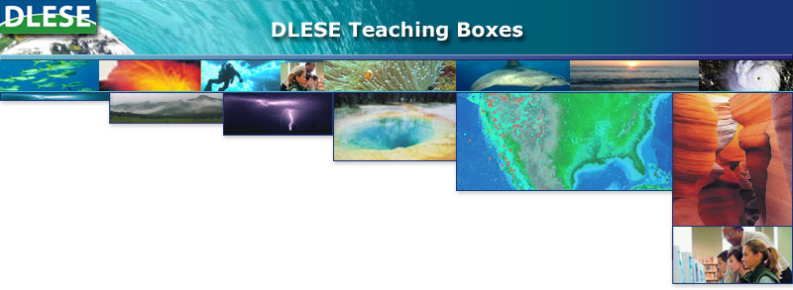**What are Teaching Boxes?**

Teaching boxes are classroom-ready instructional units created by collaboration between teachers, scientists, and designers. Each box helps to bridge the gap between educational resources and how to implement them in the classroom. The Teaching Boxes contain materials that model scientific inquiry, allowing teachers to build classroom experiences around data collection and analysis from multiple lines of evidence, and engaging students in the process of science. - focusing on gathering and analyzing scientific evidence. All educators may use DLESE Teaching Boxes free of charge.

Teaching Box features:

* Conceptual framework with the key scientific concepts that students should understand as a result of conducting the investigation
* National and state science, math, and language arts standards
* In-class lessons and activities
* Suggestions for homework and ways to extend the lessons for advanced learners
* Learner assessments and rubrics help determine student understanding
* Culminating activities to assess learning
* Selected digital library resources

The following teaching boxes topics are available:

### [Evidence for Plate Tectonics](http://www.teachingboxes.org/jsp/teachingboxes/plateTectonics/index.jsp) (6-8)

### [Essentials of Weather](http://www.teachingboxes.org/jsp/teachingboxes/weatherEssentials/index.jsp) (9-12)

### [Feeding Frenzy: Seasonal Upwelling](http://www.teachingboxes.org/upwelling/index.jsp) (6-8 with extensions for 9-12)

### [Global Ups and Downs: Changing Sea Level](http://www.teachingboxes.org/seaLevel/index.jsp) (6-12)

### [Living in Earthquake Country](http://www.teachingboxes.org/earthquakes/index.jsp) (6-12)

### [Mountain Building](http://www.teachingboxes.org/mountainBuilding/index.jsp) (6-12)

To find out more information go to - <http://www.teachingboxes.org/>

**Geography Resources:**

The Association of American Geographers (AAG) offers an array of web resources for K-12 and college-level Earth science education:

* **The Geographic Advantage** (<http://geographicadvantage.aag.org/>), an educational companion for the National Research Council’s Understanding the Changing Planet, outlines teaching strategies and geographic investigations that show students how geographers explore environmental change and sustainability.  
  
* **AAG’s Center for Global Geography Education** (<http://www.aag.org/cgge>) offers online modules for undergraduate courses in geography and related social and environmental sciences.  All modules feature a conceptual framework, regional case studies, and collaborative projects.  
  
* **GeoSTART** materials will help middle/high school students learn state-of-the-art approaches to geography, earth science, and spatial thinking skills using NASA Earth Observing Missions remote sensing imagery and related data.  Go online (<http://www.aag.org/cs/education/k12_and_teacher_education/geostart_teaching_earth_science>) for free activities and materials.

C:\Users\Kathryn Barckat\AppData\Local\Microsoft\Windows\Temporary Internet Files\Content.IE5\C42VDBP7\MC900295297[1].wmf**Mark Your Calendars!**



**Google Earth On-line Course!**

Whether you're traveling to far-off lands or staying local this summer, Google's mapping tools have you covered. Register today for Mapping with Google ([mapping.withgoogle.com](http://mapping.withgoogle.com)), a new course from [GoogleOnlineCourses](https://plus.google.com/%20GoogleOnlineCourses/posts) that helps you discover new and existing features of the new [Google Maps](https://plus.google.com/u/0/%20GoogleMaps/posts) and [Google Earth](https://plus.google.com/u/0/%20GoogleEarth/posts). Learn to plot points of attraction for an upcoming trip to share with your travel buddies, find and map all the best ice cream spots in town, or create a custom 3D tour of your summer adventures with Google Earth. Register now at [mapping.withgoogle.com](http://mapping.withgoogle.com). The course is offered from June 10 - June 24. All registrants will receive an invitation to the new Google Maps.

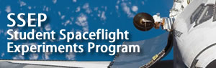Announcing the Student Spaceflight Experiments Program (SSEP) Seventh Flight

Opportunity - SSEP Mission 5 to the International Space Station for the

2013-2014 Academic Year. This is an opportunity for school grade 5-12 students to design a microgravity experiment for a flight to the International Space Station (ISS)

The Student Spaceflight Experiments Program was designed as a model U.S. national STEM education initiative to inspire and engage the next generation.

SSEP provides truly authentic STEM education experiences with seamless integration across STEM disciplines, and cross-disciplinary connections to reading, writing, communication, and art and design. And it is garnering very significant media attention at the local and national level.

**PROGRAM OVERVIEW:**

SSEP Mission 5 to ISS will provide each participating community a real microgravity research mini-laboratory capable of supporting a single microgravity experiment, and all launch services to fly the mini-lab to ISS in spring 2014. Mirroring how professional research is done, student teams across the community design their own microgravity research programs, and submit real but grade level appropriate research proposals. Proposals from across the community go through a formal review process, and the community’s flight experiment is selected by a Review Board meeting at the Smithsonian National Air and Space Museum, a National Partner on SSEP. The design competition – from program start, to experiment design, to submission of proposals by student teams – spans 9 weeks from September 9 to November 11, 2013. Content resources for teachers and students support foundational instruction on science in microgravity and experiment design.

This is a true science immersion program where students are asked to be real scientists and go through the exact same process as professional researchers vying for research resources and research opportunities. SSEP addresses a wide range of biological and physical science disciplines, including: seed germination, crystal growth, physiology and life cycles of microorganisms (e.g. bacteria), cell biology and growth, food studies, and studies of micro-aquatic life. Students design experiments to the technology and engineering constraints imposed by a real research mini-lab and flight operations to and from Earth orbit.

**MILESTONE DATES:**

9-Week Experiment Design Phase in Your Community: September 9 to November 11, 2013

Selection of Your Community’s Flight Experiment: December 12, 2013

Ferry Flight to ISS: Spring 2014

Ferry Flight Return to Earth: expectation is Launch + 6 weeks

National Conference at Smithsonian in Washington, DC: early July 2014

**TIME CRITICAL:** ALL INTERESTED COMMUNITIES ARE ASKED TO READ THIS CAREFULLY AND INQUIRE BY JUNE 30, 2013; schools and districts need to assess interest with their staff and, if appropriate, move forward with an Implementation Plan. Contact us via the SSEP home page, or call directly at: 301-395-0770

SSEP HOMEPAGE: <http://ssep.ncesse.org>

**Apply for a PLT GreenWorks! Grant**

Project Learning Tree has [GreenWorks! grants](http://www.greenworks.org/) of up to $3,000 available to schools and youth organizations for environmental service-learning projects.  The application form is now online and the deadline to apply is September 30, 2013.

PLT's GreenWorks! program is open to any PLT-trained educator in all 50 states and the District of Columbia.  The grants help students actively improve their local environments, which include both their schools and their communities.  Possible project ideas might include implementing recycling programs, conserving water and energy, improving air quality, or establishing school gardens and outdoor classrooms and integrating these projects into the curriculum.  PLT also provides grants for youth to plant trees, conserve forests, restore habitats, improve streams, construct nature trails, and more.

PLT GreenWorks! projects combine academics with service projects using the service-learning model.  In this way, students “learn by doing” through an action project they both design and implement.  The projects encourage students to partner with school decision-makers, local businesses, and community organizations to provide opportunities for student leadership.

Teachers and students can visit [www.greenworks.org](http://www.greenworks.org/) to download an application and apply today.  Successful applicants can expect grant funds to be awarded in December 2013.  All projects must be completed by December 2014.

## **NASA Launches Exploration Design Challenge**

NASA's Exploration Design Challenge provides students in kindergarten through twelfth grade an opportunity to play a unique role in the future of human spaceflight. NASA and Lockheed Martin are developing the Orion spacecraft to carry astronauts beyond low-Earth orbit and on to an asteroid or Mars. Protecting astronauts from space radiation on these distant travels is an important—and very real—problem that needs solving. NASA is looking for students to help!

Using free, standards-based activities along with print and video resources developed by leading education experts, students will learn about space radiation and human spaceflight. Students will then think and act like scientists to analyze different materials that simulate radiation shielding and make recommendations for what best blocks harmful radiation.

Students in grades 9–12 can take the challenge a step further and think and act like engineers to design shielding. Students will follow the engineering design process and work in teams to design radiation shielding to protect a sensor on the Orion crew module from space radiation. Once designs are complete, teams may compete for the chance to build their design and have it flown on the Orion Exploration Flight Test-1.

All students and educators participating in the challenge will have their name flown on Exploration Flight Test-1 as members of the virtual crew. This unmanned mission is set to launch from Florida's Cape Canaveral Air Force Station in late 2014. The deadline to register for the virtual crew is March 14, 2014.

The challenge officially launched on March 11, 2013, and thousands of students around the globe have registered to take part. Help NASA protect our astronauts as they venture to places never before attempted by human beings. Chart your journey to deep space by joining NASA's Exploration Design Challenge at [www.nasa.gov/education/edc](http://www.mmsend52.com/link.cfm?r=101801860&sid=25064315&m=2700341&u=NSTA&j=14185397&s=http://www.nasa.gov/education/edc).

**Earth Science Week 2013 – October 13 – 19, 2013**

The [American Geosciences Institute (AGI)](http://www.agiweb.org/) is pleased to announce that the theme of **Earth Science Week 2013** will be "Mapping Our World." This year's event will promote awareness of the many exciting uses of maps and mapping technologies in the geosciences.  Earth Science Week 2013 materials and activities will engage young people and others in learning how geoscientists, geographers, and other mapping professionals use maps to represent land formations, natural resource deposits, bodies of water, fault lines, volcanic activity, weather patterns, travel routes, parks, businesses, population distribution, our shared geologic heritage, and more.  Maps help show how the Earth systems (geosphere, hydrosphere, atmosphere, and biosphere) interact. For more information please go to the Earth Science Week website at <http://www.earthsciweek.org/>

For some great activities and lessons, be sure to check out the Earth Science Week Teacher link at - <http://www.earthsciweek.org/forteachers/index.html>

**The 2013 Earth Science Week Toolkit includes:**

* A 12-month school-year activity calendar, suitable for hanging
* The new Earth Science Week poster, including a learning activity
* National Park Service items on geologic maps of national parks
* NASA education materials on map technologies and resources
* A poster on careers in mapping and GIS from Esri
* A DVD of the Switch Energy Project documentary on energy
* A genuine field notebook from Rite in the Rain
* A poster on how GPS works from NOAA
* Educational material from U.S. Fish and Wildlife Service
* Energy4Me material on energy science
* A poster on minerals that make up our world
* A soil science poster from Soil Science Society of America
* A dinosaurs flyer from Bureau of Land Management
* Brochures, bookmarks, fact sheets, postcards, and more

**To pre-order the 2013 Earth Science Week Toolkit go to** - <http://www.earthsciweek.org/materials/index.html>

**[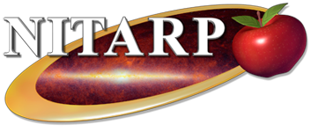](http://nitarp.ipac.caltech.edu/)April 24, 201**

Join us for our monthly Science Live Stream as we explore Rocks, Minerals and NITARP, the NASA/IPAC Teacher Archive Research Program, gets teachers involved in authentic astronomical research. We partner small groups of educators with a mentor professional astronomer for an original research project. The educators incorporate the experience into their classrooms and share their experience with other teachers. The program runs January through January. Applications are available now and due on September 23. It's available at our website: <http://nitarp.ipac.caltech.edu/>

***Please note that, due to the programmatic uncertainty surrounding NASA Education and Public Outreach (EPO) funds and activities, as of May 2013, it is not at all clear that selection of educators will be permitted for NITARP 2014 in Fall 2013. Applications are solicited in the hope it will be possible to continue NITARP. If NITARP is able to continue, expected funding levels will allow us to select just 9 new educators, a smaller class than has been possible in past years. ***

Some things that make our program different from many (if not most) other astronomy programs for educators:

(1) Each team does original research using real astronomical data, not canned labs or reproductions of previously done research;

(2) Each team writes up the results of their research and presents it in a science poster session at an American Astronomical Society meeting (the AAS is the professional organization for astronomers in the US).

(3) The program runs over 13 months, not just a few days or weeks.

(4) Teachers are encouraged to involve their students from the beginning of the program.

Most, but not all, of our educators are high school classroom educators, but 8th grade, community college, and informal educators have participated as well. The kinds of educators we are looking for are those who already know the basics of astronomy, and are interested in learning exactly how astronomy research is conducted.

For more information, please see our website (<http://nitarp.ipac.caltech.edu> ), or if you have any questions, please feel free to contact me at this email or at our central email, [nitarp@ipac.caltech.edu](mailto:nitarp@ipac.caltech.edu). Dr. Luisa Rebull - Research Scientist, Spitzer Science Center

Science Live Stream is a live broadcast featuring hands-on activities and resources from the Di [http://sciencelivestreamapr2013.eventbrite.com](http://cl.exct.net/?ju=fe38177675650579751371&ls=fdb21573766c0d7e7c1377776d&m=ff2e16777762&l=fe6815787664067c7017&s=fdf515777763007d751d747d&jb=ffcf14&t=)

**How to contact us?**

While the web page is a “work in progress”, TESTA has a new email address! You can contact one of us listed below or the following email address:

[**texasearthscienceteachers@aol.com**](mailto:texasearthscienceteachers@aol.com)

Alexia Bienek – TESTA President – [lexyb@consolidated.net](mailto:lexyb@consolidated.net)

Kathryn Barclay – TESTA Vice-President – [kathrynbarclay65@aol.com](mailto:kathrynbarclay65@aol.com)

Lisa Stone – TESTA Treasurer – [lisa.stone@fortbend.k12.tx.us](mailto:lisa.stone@fortbend.k12.tx.us)

Lale Bilir – TESTA Membership – [lale.bilir@fortbend.k12.tx.us](mailto:lale.bilir@fortbend.k12.tx.us)