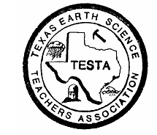 Texas Earth Science Teachers Association

The TESTA

Tailings…

May, 2013

## 

## TESTA Presents...

We would like to give a great big thank you to everyone who has volunteered to present a workshop or short course as part of the TESTA Strand at CAST 2013! This will be our largest selection of presentations that we have had to date.

**The following programs will be presented at CAST:**

For the strand, TESTA will have two or three rooms dedicated for earth science hour long workshops, and short courses that are either 3 or 6 hours in length. These presentations will also be featured on our Affiliate Page and will be flagged in the program as being part of the TESTA Strand to identify those that are specifically endorsed by our organization in the CAST program.

If you submitted an Earth/Space Science proposal to CAST and your name and program is not listed above, please contact me as soon as possible so we can get corrections done.

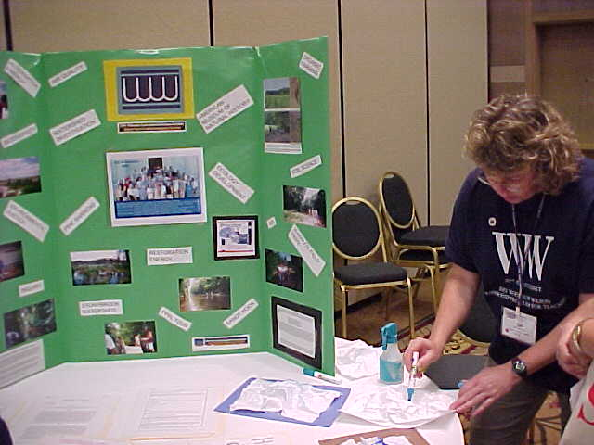**Share – A – Thon Presenters:**

TESTA would like to extend a great big Thank You to the following people who have agreed to present at the TESTA Share-a-Thon on Saturday morning of CAST 2013. Currently on the presentation list are: Denise Smith, Lale Bilir, Julie Pierce, Wanda Pagonis, Delphinia Denny, Gail Gant, Kathryn Barclay, Theresa Cooke, and Lexy Bienek. If you would like to present or I have accidently missed recording your name as a presenter, please let me know as soon as possible. We want to have all of our presenters recognized in the CAST program as being a part of the Share-a-Thon. This is a great way to be a presenter without doing a complete workshop session or a short course. It is also great for your PDAS and to promote your school and district.

**C:\Documents and Settings\kathryn.barclay\Local Settings\Temporary Internet Files\Content.IE5\U22XUUQT\MC900411061[1].wmfTESTA Teacher of the Year:**

**Congratulations to Denise Pool – TESTA Teacher of the Year - 2012 – 2013!**

Denise teaches 5th grade science at Lomax Elementary School in the La Port ISD. She has been teaching for only five years but she has been recognized as her school’s Rookie Teacher of the Year and was runner-up for Teacher of the Year for the 2011 – 12 school year. Denise also attended the 2011 Smithsonian Science Education Academy for Teaching Earth’s History & Global Change in addition to attending the *Rice Elementary Model Science Lab School* to receive intensive training in teaching Science through hands on learning with college readiness in mind for the 2010-2011 school year. In her application, Denise summarized her philosophy of teacher as follows: *“My philosophy as an educator is to present all the science I can in such a way that when our time ends each school year, every student will know that they are scientists and an active part, important part, of the world around them.”*

Every year at CAST, we honor our TESTA Teacher of the Year. Requirements for Teacher of the Year are as follows:

* Be a member of TESTA
* Teach earth science units and/or classes in a Texas public or private school for a minimum of at least 3 years.
* Apply by submitting the following items – Resume and a Letter of Recommendation from a colleague or administrator, and a one to two page essay on your philosophy of teaching.
* Applications should be submitted electronically to – [texasearthscienceteachers@aol.com](mailto:texasearthscienceteachers@aol.com)

**Denise will be recognized during the TESTA luncheon at CAST 2013. She will receive an engraved plaque, $300.00 award check, and complementary tickets to the luncheon. Please join us in congratulating Denise Pool as the TESTA Teacher of the Year!**

DELESE

<http://www.teachingboxes.org/>

### What are Teaching Boxes?

Teaching boxes are classroom-ready instructional units created by collaboration between teachers, scientists, and designers. Each box helps to bridge the gap between educational resources and how to implement them in the classroom. The Teaching Boxes contain materials that model scientific inquiry, allowing teachers to build classroom experiences around data collection and analysis from multiple lines of evidence, and engaging students in the process of science. - focusing on gathering and analyzing scientific evidence. All educators may use DLESE Teaching Boxes free of charge.

Teaching Box features:

* Conceptual framework with the key scientific concepts that students should understand as a result of conducting the investigation
* National and state science, math, and language arts standards
* In-class lessons and activities
* Suggestions for homework and ways to extend the lessons for advanced learners
* Learner assessments and rubrics help determine student understanding
* Culminating activities to assess learning
* Selected digital library resources

**C:\Users\Kathryn Barckat\AppData\Local\Microsoft\Windows\Temporary Internet Files\Content.IE5\C42VDBP7\MC900295297[1].wmfMark Your Calendars!**

**April 24, 2013**

Join us for our monthly Science Live Stream as we explore Rocks, Minerals and the processes that create them.

**April 24, 2013 1pm ET (12pm CT)**

The Science Live Stream is a live broadcast featuring hands-on activities and resources from the Discovery Education

Register at: [http://sciencelivestreamapr2013.eventbrite.com](http://cl.exct.net/?ju=fe38177675650579751371&ls=fdb21573766c0d7e7c1377776d&m=ff2e16777762&l=fe6815787664067c7017&s=fdf515777763007d751d747d&jb=ffcf14&t=)

[Register for Live Stream to view the event](http://cl.exct.net/?ju=fe36177675650579751373&ls=fdb21573766c0d7e7c1377776d&m=ff2e16777762&l=fe6815787664067c7017&s=fdf515777763007d751d747d&jb=ffcf14&t=)  
Join us for our monthly Science Live Stream as we explore Rocks, Minerals and the processes that create them.

**April 24, 2013 1pm ET (12pm CT)**

The Science Live Stream is a live broadcast featuring hands-on activities and resources from the Discovery Education S

Register at: [http://sciencelivestreamapr2013.eventbrite.com](http://cl.exct.net/?ju=fe38177675650579751371&ls=fdb21573766c0d7e7c1377776d&m=ff2e16777762&l=fe6815787664067c7017&s=fdf515777763007d751d747d&jb=ffcf14&t=)

[Register for Live Stream to view the event](http://cl.exct.net/?ju=fe36177675650579751373&ls=fdb21573766c0d7e7c1377776d&m=ff2e16777762&l=fe6815787664067c7017&s=fdf515777763007d751d747d&jb=ffcf14&t=)**1pm ET (12pm CT)**

The Science Live Stream is a live broadcast featuring hands-on activities and resources from the Discovery Education

Register at: [http://sciencelivestreamapr2013.eventbrite.com](http://cl.exct.net/?ju=fe38177675650579751371&ls=fdb21573766c0d7e7c1377776d&m=ff2e16777762&l=fe6815787664067c7017&s=fdf515777763007d751d747d&jb=ffcf14&t=)

[Register for Live Stream to view the event](http://cl.exct.net/?ju=fe36177675650579751373&ls=fdb21573766c0d7e7c1377776d&m=ff2e16777762&l=fe6815787664067c7017&s=fdf515777763007d751d747d&jb=ffcf14&t=)

**How to contact us?**

While the web page is a “work in progress”, TESTA has a new email address! You can contact one of us listed below or the following email address:

[**texasearthscienceteachers@aol.com**](mailto:texasearthscienceteachers@aol.com)

Alexia Bienek – TESTA President – [lexyb@consolidated.net](mailto:lexyb@consolidated.net)

Kathryn Barclay – TESTA Vice-President – [kathrynbarclay65@aol.com](mailto:kathrynbarclay65@aol.com)

Lisa Stone – TESTA Treasurer – [lisa.stone@fortbend.k12.tx.us](mailto:lisa.stone@fortbend.k12.tx.us)

Lale Bilir – TESTA Membership – [lale.bilir@fortbend.k12.tx.us](mailto:lale.bilir@fortbend.k12.tx.us)