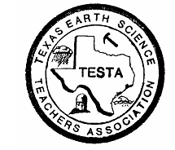 Texas Earth Science Teachers Association

The TESTA

Tailings…

**Report of the TESTA Earth Science Conference -**

On Saturday, February 23rd we had our Earth Science Conference at the Houston Museum of Natural Science in Sugar Land, TX. TESTA would like to thank the following people for presenting at the conference:

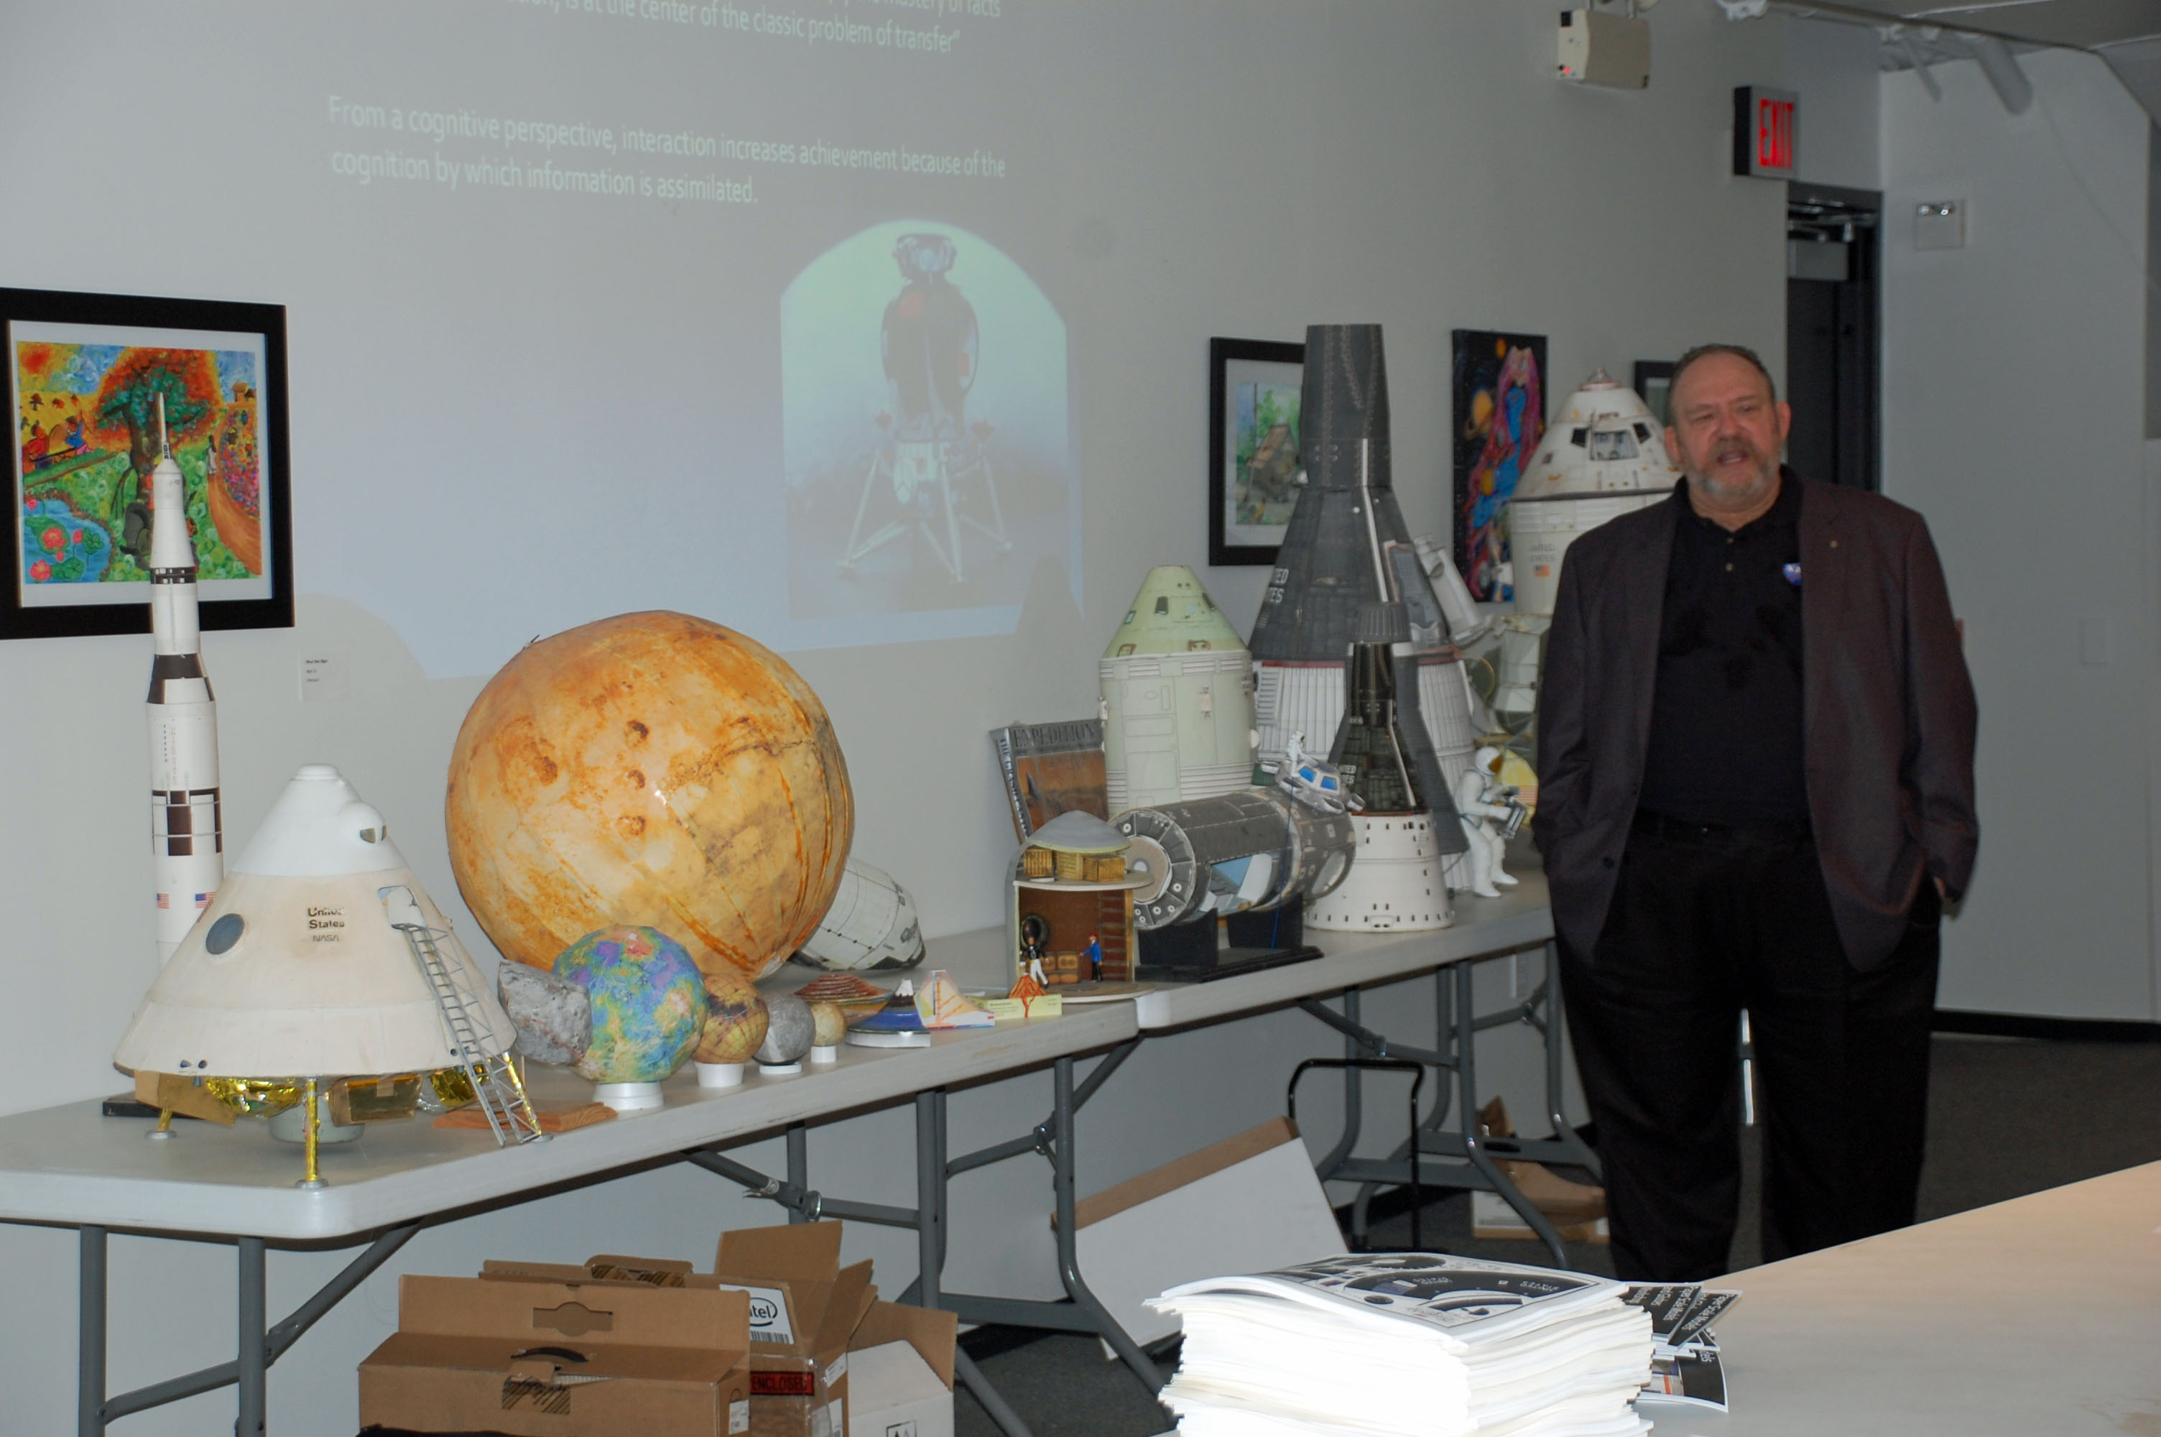**“Enhancing the Quality of Earth Science Teaching”** – Dr. Lyle Baie - Former Executive Director AAPG and Stef Paramoure – The John Cooper School – The Woodlands - 2010 AAPG Earth Science Teacher of the Year

**“Subsidence and our Aquifer”** - David Martinez – Education Program Coordinator – Harris – Galveston Subsidence District

**“"odels and Globesxed lunch and drink in the ice. cal energy is kinetic energy. Whenever we use energy to do work, it is in the Paper Scale Models and Globes Workshop – Part I and II –** Gary Kitmacher – NASA / University of Houston - Central Campus.

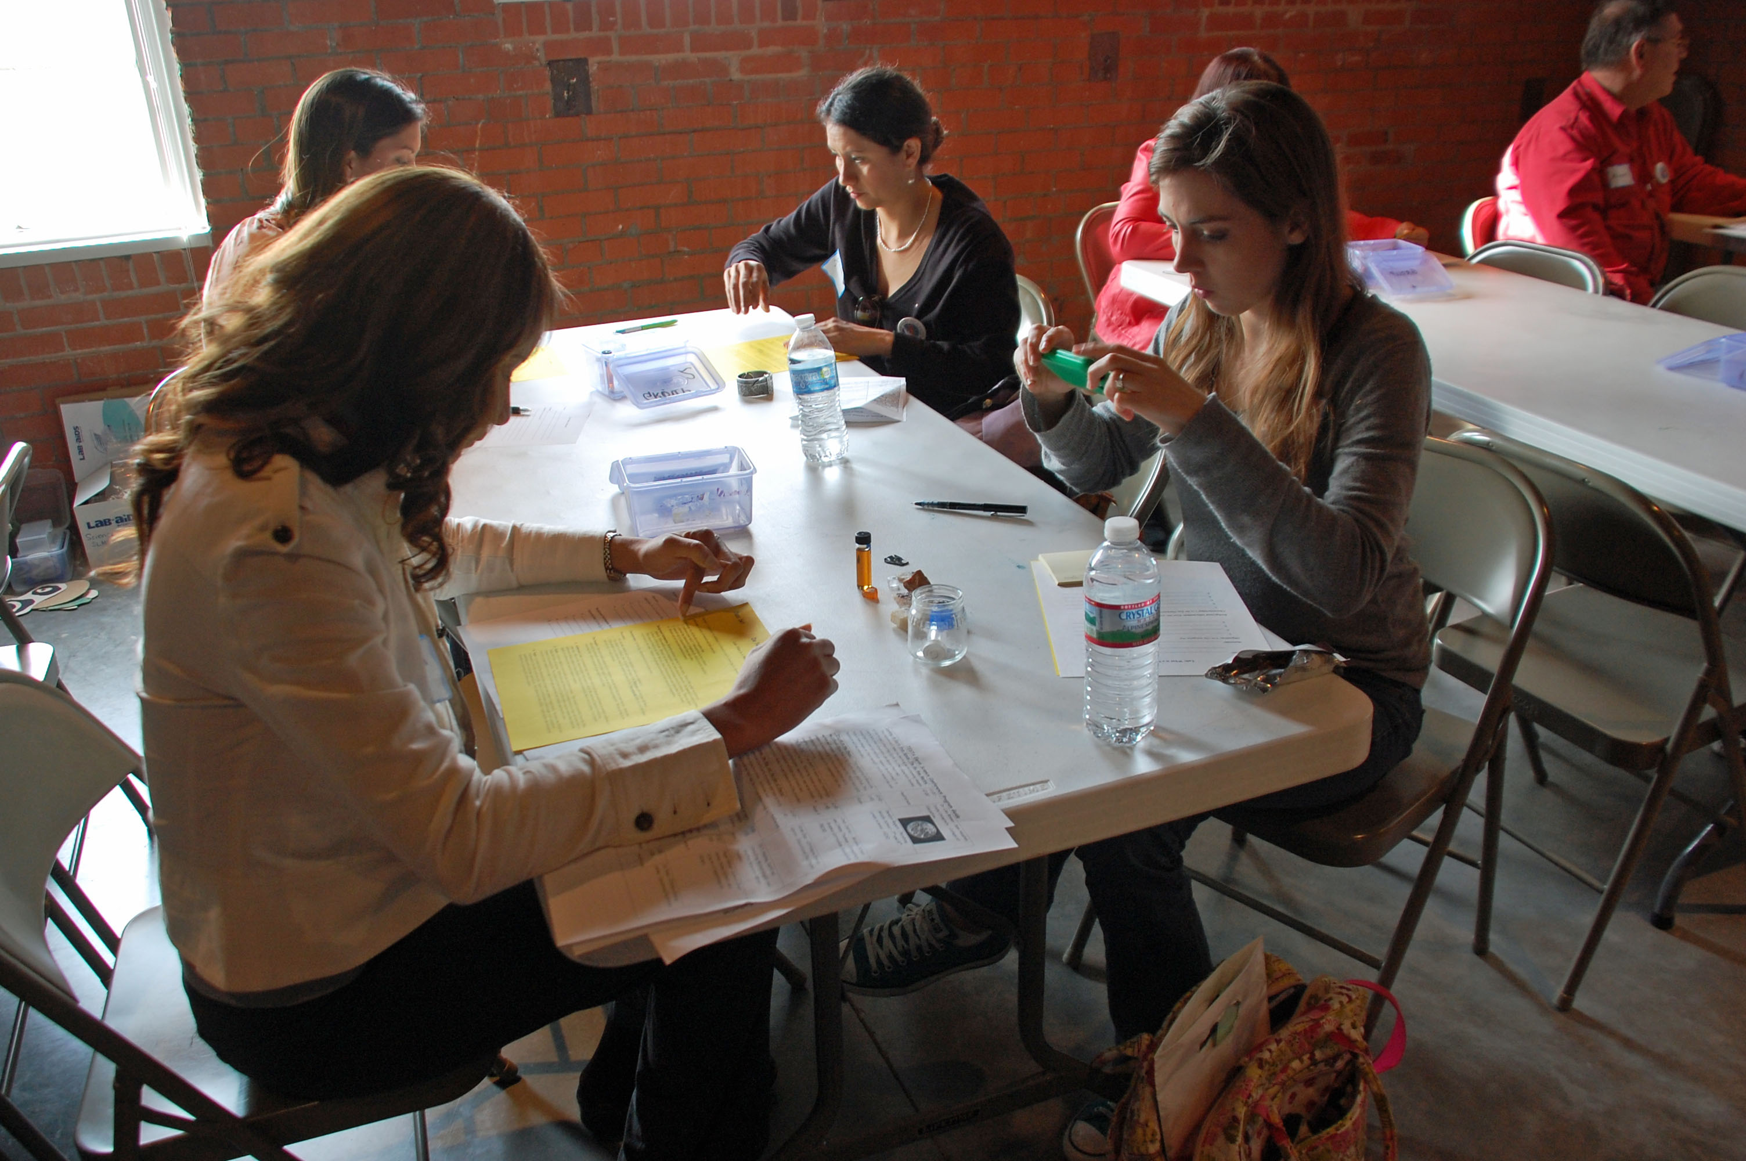**“Rocking Around with “What is a Mineral?”** – Julie Pierce – Sugar Land Middle School (FBISD) – 6th grade science teacher.

**“Shape Up for Topography”** – Lale Bilir – Sugar Land Middle School (FBISD) - 8th grade science teacher. TESTA Membership Chair

**“Looking At Earth from Space: The Big Blue Marble”** - Dr. Lisa Brown – Sam Houston State University – College of Education.

**“It’s All in the Phase”** – Devalyn Rogers – Pershing Middle School – 7th and 8th grade science - HISD

**“The Big Drip”** – Cindy Juarez - Middle School Science Curriculum Specialist – FBISD and Janet Kirksey – a retired 5th grade science teacher.

**“The Good, the Bad, and the Ugly of Energy”** – Kirah Diaz – Offshore Energy Center – Educational Facilitator

**“Weather Basics”** – Jill F. Hasling, Certified Consulting Meteorologist and Weather Research Center - President

**“Online Earth Science Maps a Playground for Inquiry”** – Roger Palmer- Science Chair Bishop Dunne Catholic and Director of operations at GISetc

**“Make and Take Rock Cycle Story Cubes”** – Joy Sloan – Offshore Energy Center – Educational Facilitator

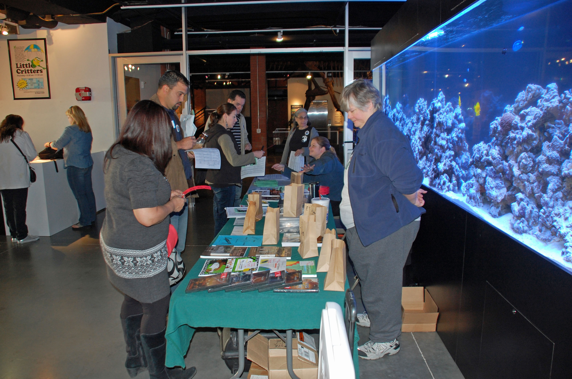We also had 11 different Science on a Sphere and 8 Discovery Dome presentations by the HMNS during the day. TESTA would like to thank Kathie Triebs with the Education Department and the staff at the Sugar Land location for all of their help in making the conference a success. Additionally, we would like to thank the people and businesses who contributed door prizes for the conference – these were Lale Bilir, John Kountz with GeoBlox, CPO, Vernier, NASCO, and Jeanne Herbes with Dina-Might Adventures.

41 teachers from across Region IV and as far away as San Antonio and Dallas registered and attended the conference. According to the evaluation feedback the overall conference value and experience was rated a 4.2 on a 5 point scale and they overwhelmingly would attend again. We are already working on plans for our 2014 Earth Science Conference.

**Report of the Science Teachers Association of Texas (STAT) Board Meeting:**

Alexia Bienek, TESTA President, attended the STAT board meeting on February 22, 2013 in Austin, Texas. TESTA is an affiliate member of the STAT organization and is represented on the STAT Board by our president. To maintain our affiliation we must meet certain conditions such as filing financial and member ship reports, maintain a representation at the STAT board meetings, and ensuring that at least 51% of the TESTA members are also members of STAT.

The main agenda item at the February meeting was to give an update on the timeline for CAST 2013 in Houston and to review the Mission, Goals, and By-Laws of the STAT organization. By now, members should have received a STAT flash outlining changes in the by-laws of the organization. Listed below is the revised Mission Statement and Goals as set by STAT:

**STAT MISSION –**

The mission of the Science Teachers Association of Texas (STAT) is to build a community dedicated to advancing science teaching and learning.

**STAT GOALS –**

* Build and strengthen networks for Texas science educators;
* Disseminate current scientific and educational research;

Run a research strand at CAST; affiliates enlist researchers from their field to present

Recent research activities concerning that field

* Provide quality professional growth opportunities in content and pedagogy;

Increase affiliate activities beyond CAST

Summer Leadership academy

* Communicate with policy makers and the public regarding science education issues;

Invite local politicians, businesses, and other interested parties to CAST

* Establish STAT as a resource for science education so that all students are scientifically and technologically literate, responsible, and productive citizens.

**C:\Users\Kathryn Barckat\AppData\Local\Microsoft\Windows\Temporary Internet Files\Content.IE5\C42VDBP7\MC900295297[1].wmfMark Your Calendars!**

## Here is your chance to be a part of CAST, not just an attendee!

## TESTA Presents...

We are in the process of building the TESTA Strand for the Thursday, Friday and Saturday of the conference.

For the strand, TESTA will have two or three rooms dedicated for earth science hour long workshops, and short courses that are either 3 or 6 hours in length. These presentations will also be featured on our Affiliate Page in the CAST program. Additionally, these workshops will be flagged in the program as being part of the TESTA Strand to identify those that are specifically endorsed by our organization. If you are interested in being a part of the strand, please send us a brief description of your proposal so we can plan the program.

In addition to the strand of workshops and short courses, we will also conduct our Share-a-Thon on Saturday morning of CAST. This is a great way to present that favorite lesson or activity that you have developed and want to share with others without doing a full hour long presentation. For the Share-a-thon, we try to have from 15 to 20 TESTA members each at a table along the walls of a large room. During the session, participants will come in and circulate around the tables within the room stopping at tables to see the activity, lesson or student models. As the presenter you will continuously talk to small groups of teachers.

If you would like to present at the Share-a-Thon please be sure to contact TESTA as we will enter this proposal and include your name as one of the presenters for the CAST program.

Proposals for CAST 2013 will open on the STAT website March 15th and will close on May 8th. ***If you are interested in presenting a workshop or short course as part of the TESTA strand please contact us as soon as possible.*** There are specific directions for entering proposals under an Affiliate Strand. If you enter a proposal directly on the web site without contacting us it will **NOT** be a part of the TESTA Strand!

**C:\Documents and Settings\kathryn.barclay\Local Settings\Temporary Internet Files\Content.IE5\1908OQQW\MC900155711[1].wmfFossil Collecting Field Trip!**

**Brownwood, TX – March 16, 2013**

Explore the Pennsylvanian Period with Lexy Bieniek, TESTA President, and the Paleo Section of the Houston Gem and Mineral Society. We will study the formation of sedimentary rocks and use fossils to learn about the Pennsylvanian environment in Texas. Fossils can be collected for the classroom. Experts will also be available to identify those fossils. **CTE hours will be given.**

***Bring ziplock bags, hand shovels, hammers, note cards/book and sharpies***

Meet at Lexy’s house in Brownwood, 1509 Vincent, Brownwood Texas 76801 at 9 am on March 16. For more on this field trip, visit HGMS.org punch field trips. Please let Lexy know your are coming at [lexyb@consolidated.net](mailto:lexyb@consolidated.net)

Hope to see you there!

**The 15th annual National Groundwater Awareness Week -  
March 10-16, 2013**

This is part of a growing national movement to raise public awareness about groundwater and water well stewardship. For more information, go to <http://www.ngwa.org/Events-Education/awareness/Pages/default.aspx>.

**Solar Week - March 18-22, 2013**

Celebrate the Sun-Earth Connection in your Classroom. Interact live with solar scientists during Solar Week. <http://www.solarweek.org/cms/>

**Sun-Earth Day - March 22, 2013**

Sun-Earth Day is comprised of a series of programs and events that occur throughout the year culminating with a celebration on or near the Spring Equinox. Each year we wrap a fresh new thematic approach around Sun-Earth science while highlighting Heliophysics scientists, their missions, and research. <http://sunearthday.nasa.gov/2013/about/about.php>

## TESTA Annual Board of Directors Meeting –

## The leadership of TESTA will hold their annual Board of Directors Meeting on Saturday, April 6th in Cut-N-Shoot, Texas. It is during this annual meeting that we work on our plans for the CAST conference (booth, strand, share-a-thon, and rock raffle), TESTA luncheon and Annual Membership Meeting, awards, and other activities that will be held during the coming year. We also review and write our budget for the year and hold our change of officers as needed during this meeting. TESTA officers serve a two-year term and the next election will be held in early 2014 for President-elect, Vice-President, Secretary, and Treasurer.

## NSTA National Conference— Henry B. Gonzalez Convention Center San Antonio, Texas - April 11–14, 2013

## During the NSTA conference, TESTA will assist our national affiliate, National Earth Science Teachers Association with their activities, especially with their Share-a-Thons and Rock Raffle. We are planning to put together small bags of Texas specific rocks and fossils to be distributed during the Rock Raffle. If you are in the Houston area and would like to help with this endeavor please contact us. If you are interested in presenting at one of the NESTA Share-a-Thons please contact Michele Harris – Share-a-thon coordinator at [michelle_harris@apsva.us](mailto:michelle_harris@apsva.us) She still has space for presenters and there is still time to get your name in the NSTA Conference Program – but you need to act fast.

## Here is their plan for NSTA -

**All NESTA sessions are in the Henry B. Gonzalez Convention Center, Ballroom A unless otherwise indicated**

**Friday, April 12**

➢ 9:30 – 10:30 am **NESTA Geology Share-a-Thon**

➢ 11:00 am – noon **NESTA Oceans and Atmospheres Share-a-Thon**

➢ 12:30 – 1:30 pm **NESTA Earth System Science Share-a-Thon**

➢ 2:00 – 3:00 pm **American Geophysical Union Lecture, “*The climate science debate: What does the science tell us and why people on both sides are so angry about it”, Prof. Andrew Dessler,*** Texas A&M University (Grand Ballroom C1)

➢ 2:00 – 3:00 pm **Climate Change Classroom Toolkit**

➢ 3:30 – 4:30 pm **Let’s Get Well Grounded!**

➢ 6:30 – 8:00 pm **Friends of Earth Science Reception** (Grand Hyatt Hotel, Lone Star D)

**Saturday, April 13**

➢ 8:00 – 9:00 am **Activities across the Earth System**

➢ 9:30 – 10:30 am **Exploring Planetary Science and Astronomy – What Would Galileo Do?**

➢ 11:00 – noon **NESTA Space Science Share-a-Thon**

➢ 12:30 – 1:30 pm **NOAA-Sponsored NESTA Advances in Earth and Space Science Lunchtime Lecture, Mark Neilsen, Howard Hughes Medical Institute – *“If these rocks could talk: Earth’s climate in the deep past”***

➢ 2:00 – 3:00 pm **Our Changing Planet**

➢ 3:30 – 4:30 pm **NESTA Rock and Mineral Raffle**

➢ 5:00 – 6:00 pm **NESTA Annual Membership Meeting**

**Dr. Louis Jacobs, a TESTA member and supporter, will be one of NSTA’s Featured Speakers in San Antonio!**

Sponsored by Shell Science Seminars - Friday, April 12 10:30 AM–12:00 PM

**Science Seminar: Icons and Innovation in Paleontology -** *Henry B. Gonzalez Convention Center, Grand Ballroom C3*

Fossils have long been a gateway to science for learners of all ages because of the imaginative appeal of ancient creatures, lost worlds, extinction, and the evolution of our own species. Like all sciences, paleontology has made great strides in recent years. Paleontology has been reinvigorated by new discoveries focused on innovative ways to visualize fossils and search for biomolecules that relate to issues of broader societal and scientific relevance. Based on personal field and laboratory studies, Louis will highlight new directions in this field, including a fresh look at the most prominent icon of modern geology—the puzzle-like fit of Africa and South America.

*Presenter(s): Louis L. Jacobs (Professor of Earth Sciences, and President, Institute for the Study of Earth and Man, Southern Methodist University: Dallas, TX)*

**Biography:** 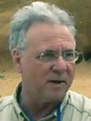

Louis Jacobs is a vertebrate paleontologist who utilizes the fossil record to answer significant questions about Earth and life history. His fieldwork is currently focused on the iconic, puzzle-like fit of Africa and South America, as viewed through the rocks and fossils of coastal Angola. Internationally recognized for his fossil discoveries, seven fossil species have been named for him, including *Malawisaurus*, which he discovered in Malawi.

At present, he is a professor in Southern Methodist University’s Roy M. Huffington Department of Earth Sciences in Dallas and president of the Institute for the Study of Earth and Man at SMU. He also serves on the National Park Service Science Committee Advisory Board.

Among his publications are *Quest for the African Dinosaurs: Ancient Roots of the Modern World*, *Lone Star Dinosaurs*, and *Cretaceous Airport*, as well as more than 100 scientific papers and edited volumes.

Louis received his PhD in geology from The University of Arizona in 1977.

**TESTA Teacher of the Year –**

Every year at CAST, we honor our TESTA Teacher of the Year. Applications are currently being taken to be considered for our 2013 Award. Requirements for Teacher of the Year are as follows:

* Be a member of TESTA
* Teach earth science units and/or classes in a Texas public or private school for a minimum of at least 3 years.
* Apply by submitting the following items – Resume and a Letter of Recommendation from a colleague or administrator, and a one to two page essay on your philosophy of teaching.
* Applications should be submitted electronically to – [texasearthscienceteachers@aol.com](mailto:texasearthscienceteachers@aol.com)
* Applications are due by May 1, 2013.

**The selected Teacher of the Year will be recognized during the TESTA luncheon with an engraved plaque, $300.00 award check, and complementary tickets to the luncheon.**

[](http://www.tmra.com/)

**Texas Mining and Reclamation Association:**

### Looking for a way to WOW your students and add new activities to your classroom?

Apply to join us for a free summer workshop full of classroom activities to stimulate your students thinking skills with hands-on labs. Teachers in grades 4 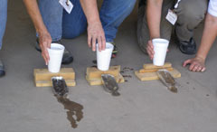through 12 will benefit from attending this workshop!

#### Great Classroom Activities

Actually do basic steps required in evaluating, planning, and designing a lignite mine. Experience the processes involved in planning and carrying out land restoration. The objective of each curriculum unit is to provide an opportunity to learn and then apply knowledge to a real problem.

***Hands-on Experience***

There is nothing like firsthand experience to add to the validity of the information you present to your students. You saw it, you did it, and you can talk about it because you were there. Participate in field work as well as classroom activities.

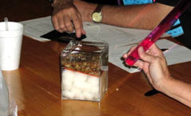**Coal Camps –**

June 16 – 21 – NAC Sabine Mine, Longview, TX

June 23 – 28 – Westmoreland Coal’s Jewett Mine, Jewett, TX

July 7 – 12 – Luminant’s Big Brown Mine – Fairfield, TX

**Industrial Mineral’s Camp –**

July 21 – 26 – Round Rock, TX

**Uranium Camp –** This camp is full! Better luck next year!

July 28 – August 2 – Mestena Mining LLC – Corpus Christi, TX

**For more information or to complete an application to attend a camp, please visit the TMRA website at http://www.tmra.com/teacher-workshop**

**How to contact us?**

While the web page is a “work in progress”, TESTA has a new email address! You can contact one of us listed below or the following email address:

[**texasearthscienceteachers@aol.com**](mailto:texasearthscienceteachers@aol.com)

Alexia Bienek – TESTA President – [lexyb@consolidated.net](mailto:lexyb@consolidated.net)

Kathryn Barclay – TESTA Vice-President – [kathrynbarclay65@aol.com](mailto:kathrynbarclay65@aol.com)

Lisa Stone – TESTA Treasurer – [lisa.stone@fortbend.k12.tx.us](mailto:lisa.stone@fortbend.k12.tx.us)

Lale Bilir – TESTA Membership – [lale.bilir@fortbend.k12.tx.us](mailto:lale.bilir@fortbend.k12.tx.us)