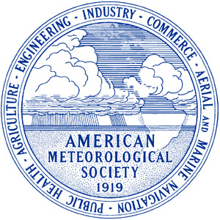

AMS’s K-12 Science Teachers
Educational Outreach Initiative
6–8 January 2013
AMS 93rd Annual Meeting, Austin, Texas
Austin Convention Center

Purpose: Connect teachers with some of the most innovative and forwarding thinking scientists in our Nation and to create a partnership to enhance our Nation’s ability to understand the causes of and response to severe weather events.
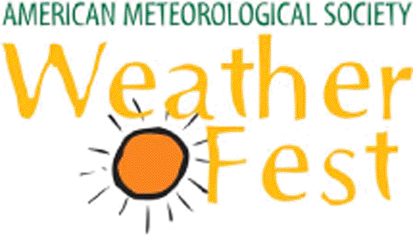
Opportunities abound to interact with our nation’s weather and climate experts through WeatherFest, Teacher Workshop, Teacher Short course and the Symposium on Education.
Get Ideas for Classroom Activities. Opportunities to attend or participate in the event demonstrations. See website for more details: http://www.wxfest.org
SUNDAY:

MONDAY: TEACHER WORKSHOP: Weather – Climate – Ocean – Basics
-- Focus on K–8 (8:00 a.m.–12:00 p.m.)
– CE Credits Awarded
Other Monday Activities
Symposium on Education: 1:30–5:00 p.m.
AMS Exhibits Open : 5:30-7:30 p.m.
Hot Science Cool Talks – Dr. Kerry Emmanuel – 7:00 p.m - UT
TUESDAY: TEACHER SHORT COURSE: Weather – Climate – Ocean - Indepth
-– Focus on High School (8:00 A.M.-5:00 P.M.)
– CE Credit Awarded
Other Tuesday Activities
MEET THE SCIENTISTS AND ENGINEERS
Symposium on Education: 8:30 a.m.–5:00 p.m.
AMS Exhibits Open: 9:30 a.m. –6:00 p.m.

OTHER CONFERENCE OPPORTUNTIES
- Interact with the Nation’s premier scientists.
- Get your weather questions answered.
- Meet the people who build the satellites – make the weather forecast etc – and research the weather and the oceans.

For more information or to register:
AMS 93rd Annual Meeting site: http://annual.ametsoc.org/2013
Email: Jill F. Hasling – wrc@wxresearch.org


