EROSION: IT’S ELEMENTARY DEAR TEACHER

Erosion doesn’t act alone. Erosion’s partner in crime is weathering. Weathering breaks rock into sediment allowing erosion to then move it from place to place.

WEATHERING
Weathering is the breaking down of rock into sediments without moving the sediments. Weathering can occur on the surface of the Earth or below the surface.
There are two types of weathering, physical and chemical. Physical weathering occurs when the rock is demolished to sediments without changing the chemical makeup of the rock. Examples of physical weathering processes include action of plants, animals, temperature changes and the erosion of overlying rock.
The roots of plants grow down through the rock causing fissures. As the plant grows, the root grows longer and wider and the fissure in the rock responds by growing longer and wider. As the root grows the fissure grows until the rock breaks.
Rocks heat up and cool down each day. As the rock heats it expands and contracts as it cools. The greater the difference in day and night temperatures, the greater the stress on the rock and the more likely it will break. During cold weather the water freezes in the small cracks. When water freezes it expands. So, as the water repeatedly freezes then thaws, the fissure expands forcing the fissure to widen with each freeze until it eventually breaks the rock.
Erosional processes, natural or man made, remove the protective overburden above the bedrock. Underlying rock responds by rising. As the rock rises it cracks enabling the natural forces wind, water and gravity to take over breaking the rock into sediments. This process is called unloading.
The process of chemical weathering involves the alteration of the internal structure of the rock by addition or removal of elements. Water is almost always involved in chemical weathering. Water falling through the atmosphere becomes slightly acidic. When this mild acid falls on rocks, the minerals in the rock react and change. Silicates are the most common mineral group. They have silicon and oxygen in varying amounts along with a large variety of other elements. When the slightly acidic rain falls on a silicate the hydrogen atoms move into the crystal structure of the silicate and begin to break down the crystal structure of the mineral. Feldspar is a silicate mineral that is altered by this process into clay. The limestone of the hill country is dissolved much the same way. When water and oxygen act on the iron minerals in the rocks, the rocks “rust” just as a bicycle left in the rain rusts. These chemical changes help to move and redistribute mineral material throughout the environment
Pioneer plants such as lichens and mosses exude enzymes through their holdfasts. These enzymes are among the most powerful chemical weathering agents in nature. The enzymes break the rock into nutrients, which are absorbed by the organism. Detritus builds up beneath the plant until the fledgling soil is too deep for the holdfasts to reach the rock then the mosses and lichens die, encyst or just move to a neighboring rock leaving a fine layer of soil that will allow wandering seed to germinate and grow.
The most important product of weathering is soil. Soil is the accumulated mixture of rock bits, organic matter, mineral material containing water and air with the ability to support life particularly plant life. Both chemical and mechanical weathering are involved in the formation soil. Mechanical weathering is responsible for the rock particles while chemical weathering secures the minerals and nutrients needed for the growth of plants and animals found in the soil.
Soil formation follows two pathways. Transported soils are formed by the deposition of sediment. Even though these soils do not have a recognizable pattern of development, they contain the bits of rock, organic matter, minerals along with water and air necessary to support life.
Residual soils develop as the bedrock is slowly weathered into smaller and smaller pieces until it reaches size of sand or clay particles. The process of developing residual soils forms a sequential profile moving from large pieces of bedrock at the base and topped with a covering of nutrient rich material that can support plants. The individual layers of a soil profile are called horizons.
Residual soil formation depends on several factors:
- Nature of the parent bedrock
- Climate
- Length of time the soil takes to form.
- Slope of the land on which the soil develops
- Type and extent of plant cover

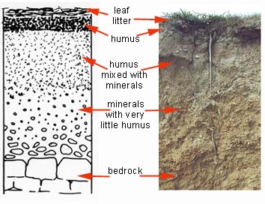
Soil Profile-Residual Soils

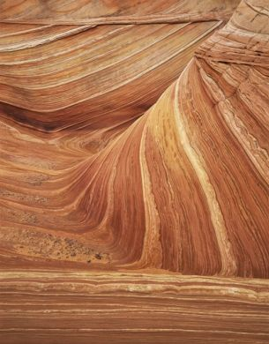

Profile- Transported Soils

There are basically three soil types determined by climatic differences.
- Pedalfer soils form in temperate, humid climates where there is enough precipitation to leach materials out of the soil concentrating the products elements such as aluminum and iron. Usually pedalfers are fertile but acidic soils.
- Pedocal soils form in drier climates where precipitation is insufficient to leach the material of chemical weathering particularly calcium carbonate out of the soil. These products concentrate in layers of caliche, which is familiar to most Texans. The amount of calcium carbonate makes the soil alkaline
- Laterite soils form in tropical areas where precipitation is so extensive and frequent and the temperature is high that only the most insoluble products remain. Laterite is very infertile soils and most common in the tropical rain forests. Laterites are sometimes classified as extreme pedalfers.

A good Texas rule of thumb is that pine trees love pedalfer soils and mesquites love the pedocal soils. In Texas there is a soil boundary. The boundary is determined by amount of rain. Pedalfer soils need 30 inches of rain per year to develop while the pedocals need less. This boundary can be observed by driving east from San Antonio to Houston. Just outside of Houston, the trees change abruptly from mesquites to pines signaling the change in soils.

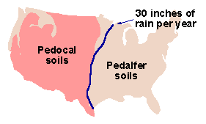

The color of the soil is a good indicator of the nutrients found in the soil. Soils rich in organic matter are usually black or brown. Soils that are white, gray or just paler have less organic matter. Organic matter is the major source of nutrients for plant growth. Soils that are rich in organic matter also have an aroma that is pleasurably unique but indescribable just as any farmer or gardener. Soils that have yellow or red tints contain iron which has been oxidized by oxygen in the air or in the water found in the soil.
Water and air are necessary parts of soil if plants are to grow. Plants must be able to pull these elements from the soil. The soil must be porous and permeable to allow the water and to flow through it. Pores are spaces between the rock, mineral and organic grains in the soil, which store water and air. In order for the fluids to flow through the soil, these spaces must be connected. This connection is called permeability.
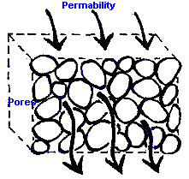

Soil texture refers to the size of the grains that compose the soil. Clay is less than .002 mm. Silt is a bit larger at .05-.002 mm. This roughly compares to the size of the particles making up baby powder. Sand ranges in size from 2-.05 mm. The soils are named for the most common grain found in the soil. Loam is an equal mixture of sand, clay and silt.
The grain also determines the porosity and permeability of the soil. Clay particles are flat and lie on top of one another much like a deck of cards giving clay a very low porosity and virtually no permeability. Silt grains are more rounded and lock together in a manner that increases both the porosity and permeability giving the silt based soils the ability to store water. Sand forms rounded grains that do not lock together making sand based soils very porous and permeable. But sandy soils without a great deal of organic matter are unable to store water making them poor agricultural or gardening soil.
Rocks are also porous and permeable. Aquifers must be porous and permeable in order for the water to flow through them. Petroleum reservoirs are also porous and permeable for the same reason.

Mechanical weathering ActIVITIES
Root Pry
Time 5-6 class periods
1 period to mix plaster and plant bean seeds
1 day for mixture to dry
2-3 days for seeds to germinate
1 day to write up
(the end product can be thrown away or planted depending on your grade level)

Materials
Lima beans
Paper cup
Plaster of paris or masonry concrete
Water
Dish-pie pan for individuals, cookie sheet for a class

Procedure
- Mix plaster of paris or masonry concrete
- Put 2 or 3 lima beans in a paper cup
- Pour plaster of paris over the seeds
- Let it dry (time depends on type of plaster of paris used)
- Once it is dry, peel away the paper cup
- Put water in the dish
- Place cup contents into water
- Check water level daily
- Have students record observations daily
- Seeds should germinate in 2-3 days

Results-as seeds geminate they should break the plaster of paris. Let the germination continue until the cotyledons break the plaster of paris into smaller pieces.

Extensions
- Plant the seeds and let them continue to grow
- Locate places on the school grounds where plants have come up through the sidewalk or pavement. Have students explain what will happen to the sidewalk or pavement if the plant is allowed to continue to grow
- Find and older area of town or visit an old cemetery and take pictures of places where roots have cracked, moved or engulfed sidewalk, concrete or headstones.

Frost Wedging
Time-overnight
Materials
- Unopened can of soft drink
- pieces of very porous broken concrete or pavement

Procedure
- Can of soft drink
  - Discuss what the can looks like
  - Place the unopened can in a freezer
  - Remove can next day
  - Record the changes
- Concrete/pavement
  - Have students describe the concrete encourage the students to find cracks in the “rock”
  - Soak concrete in water until it is saturated
  - Place concrete in freezer
  - Remove and let students describe it; again emphasize the cracks
  - Let the concrete return to room temperature
  - Soak in water again
  - Put it back in the freezer
  - Continue this process until concrete begins to break

Results
- Can of soft drink should “pop” overnight
- Bits of concrete should “pop” within a couple of days. If not-secretly “pop” it by hitting the samples softly with a hammer. The samples need to be covered before hitting them because the hammer will leave flat strike mark where it contacts the sample. Inevitably, one observant student will notice this mark and begin a lengthy distracting explanation.

Abrasion
Time-
1 class period

Materials
- 2 Small pieces of sandstone or sugar cubes for each student
- 35mm film canisters
- Paper towels or paper plates

Procedure
- Have students write a description of the sandstone or sugar cubes
- Place the sandstone/sugar cubes in a 35 mm film container and shake for 3 minutes
- Pour the contents out onto a paper towel or plate
- Have students write another description of the contents and an explanation about the origin of the sediment.

Results
The sandstone or sugar cubes should readily fall apart during the shaking producing quite a bit of loose sand or sugar in the container. This does get messy. Be prepared with a broom, whiskbroom and dustpan for accidents.

Extensions

Add this equipment to the materials list
Metric ruler
Balance
- Have students measure the sugar cubes with the ruler and calculate the volume of the sugar cube (V=s³) before they put it in the film container. Then recalculate after the activity. The second calculation will be difficult because the sugar cube is no longer a cube. Have students explain what happened.
- Have students weigh the sugar cube or sandstone before the activity. Then have them weigh the sugar cube or sandstone after the activity plus the loose sand or sugar. The sugar cube or sandstone will not weigh the same alone but will come pretty close when the loose material is added.
CHEMICAL WEATHERING ACTIVITIES
Bubble it away!
Time
1 week

Materials
- Vinegar
- Box of chalk
- Clear plastic cups
- Graduated cylinders or other device for measuring liquids

Procedure
- Break sticks of chalk into pieces about 1 inch long
- Give each student a piece of chalk and a plastic cup
- Have students describe the piece of chalk
- Put the chalk into the cup
- Measure about 20 mL of vinegar
- Pour over chalk
- Have students describe results
- Set cup and vinegar aside
- Observe and record daily

Results
Initially the chalk will bubble nicely. Bubbling will continue until the outside of the chalk is soaked with vinegar building up a coat where the chalk is no longer reactive. If the vinegar has not been neutralized, scratching the chalk will cause the bubbling to begin. If the vinegar is neutralized then there will be no reaction and every thing stops.
Even if the reaction stops, the chalk will eventually break into smaller pieces but it may take longer than suggested.
Most vinegar sold in stores today is 5% vinegar. Pickling vinegar is 10%. It can be found in some feed stores that have a home canning section. The reaction works much better with 10% vinegar than 5% vinegar.

Extensions
Have students calculate the volume of the piece of chalk.

Oxidation
Time
2-3 days

Materials
- Plain steel wool
- Sand
- Water
- Clear plastic cups
- Balance

Procedure
- Cut or tear the steel wool into small pieces
- Give each student a plastic cup
- Put about 25 grams of sand in the cup
- Add a piece of steel wool
- Have students describe the sand and steel wool
- Sprinkle with water
- Set aside
- Next day have students observe and record changes
- Continue until the steel wool has “rusted” away

Results
The steel wool should start rusting quickly. As the steel wool rusts, the rust will flow into the sand discoloring it. The steel wool will crumble into small pieces.

Extensions
Find a piece of Texas limestone containing pyrite. Soak the limestone in water. Keep the rock wet for several days. Rusty streaks should appear.

Social Studies in Science
The builders of the Texas capitol wanted to build a capitol building that looked just like the United States capitol in Washington using only Texas resources. As one group of men was in the capitol measuring the building, another group set Texas prisoners to mining limestone at Convict’s Hill just outside of Austin. Stacks of limestone were sitting on the ground waiting for the measuring crew to return. Rain fell on the stored blocks and rusty colored streaks began to appear on the white rock. The builders were aghast.
They regrouped and decided to use the Town Mountain granite found outside of Marble Falls to use on the outside of the building and use the limestone to face the walls on the inside.
The Texas capitol was built entirely from Texas resources including the large hinges on the doors. As for the men who went to Washington to measure the national capital, their measurements were taken by stepping off the length and width. The dome, however, was a challenge since they could not “step off” the height of the dome. An accurate measure was impossible resulting in the dome of the Texas capital being seven feet higher than the dome of the national capital.
Evaporation
Time
2-3 days
Materials
Method 1
- Salt, sugar, alum, Epson salt
- Water
- Shallow dish

Method 2
- Empty plastic water bottle
- Crushed limestone (crushed chalk can be used also)
- Water
- Beaker
- Shallow dish
- Small amount of cheese cloth
- Rubber band

Procedure
Method 1
- Heat the water
- Stir in sugar, salt or alum until no more will dissolve in the water
- Allow solution to cool
- Give each student or student group 50-75 mL of the solution
- Pour the solution into a shallow dish
- Write observations
- Set the dish in a quiet area
- Observe daily until all of the water evaporates

Method 2-closely simulates natural processes
- Cut the bottom out of the plastic water bottle
- Place the cheese cloth over the mouth of the bottle
- Secure cheese cloth with the rubber band
- Invert the bottle
- Fill bottle with crushed limestone
- Pour water into limestone
- Collect the water in the beaker
- Pour water into shallow dish
- Write observations
- Set dish in a quiet area
- Observe daily until all of the water evaporates.

Results
Water in the solution will evaporate leaving a mineral coating on the dish.

Extensions
Added materials
Hand lens or dissecting microscope
The substances in Method 1 will form crystals. Salt, sugar and alum grow cubic crystals while Epsom salt grows a different shaped crystal.

Precipitation
Time
Overnight

Materials
1. 1% solution of Copper Sulfate in dropper bottle
2. 1% solution of Barium Chloride or Calcium Chloride in dropper bottles
3. Test tubes
4. Test tube rack

Procedure
- Put 10 drops of copper sulfate into test tube
- Add 10 drops of barium chloride or calcium chloride
- Record result
- Place test tube in the test tube rack
- Set in a quiet place overnight
- Observe and record observations the next day

Results
Copper sulfate is a blue liquid while calcium and barium chloride are clear liquids. When they are mixed, the mixture turns cloudy resembling milk. The contents will settle during the night leaving a clear liquid on top of a white sediment- if chemicals are mixed perfectly. Otherwise, there will be a much lighter blue liquid with a white sediment at the bottom of the test tube.

Extensions
Use the formulas for the chemicals and determine what new substances were produced.
Copper Sulfate-CuSO₄
Barium Chloride-BaCl₂
Calcium Chloride-CaCl₂
Generalized equations
CuSO₄ + BaCl₂ -> CuCl₂ + BaSO₄
CopperII Sulfate + Barium Chloride -> CopperII Chloride + Barium Sulfate

CuSO₄ + CaCl₂ -> CuCl₂ + CaSO₄
CopperII Sulfate + Calcium Chloride->CopperII Chloride + Calcium Sulfate

SOIL

“Snake” test
Clay-gently roll the soil between your hands. If the soil will roll into a “snake” then it has clay. The better the “snake” forms the more clay in the soil.
Sand-roll the soil between your fingers. The gritty feel is the sand.

Examining Soil
Time
1 class period

Material
- Dissecting Microscope or hand lens (EPA will supply hand lenses contact http://www.epa.gov/waterscience/biocriteria and order)
- Petri dish or other shallow dishes
- Various types of soils
- Simple identification key for organisms found in the soil
- Toothpicks

Procedure
- Spread soil into shallow dish
- Observe the soil with naked eye
- Record observations
- Have students separate living and nonliving substances in the soils
- Use hand lens or dissecting scope to examine the soil for smaller organisms, sand grains and organic matter in the soil
- Have students separate living and nonliving substances in the soils
- Record observations
Results
Students should find a variety of active soil organisms, sand grains etc.
Extensions
This is a good place to address the concept of differentiating living from nonliving substances. This is an extremely difficult concept for youngsters to accept. It is hard for them to understand that a dead branch is part of the living community.

Porosity/Permeability Activities
Porosity and permeability are difficult concepts to understand even as adults. Here is a good introductory activity to help students grasp the concepts and understand the relationship between them.

Austin Chalk and his Jar of Rocks
Time .5 class period

Materials
Clear jar preferably plastic
Coarse gravel or marbles
Boxes of salt (2) or couple of lbs of salt depending on size of jar and how many times this demo will be done
Water

Teacher demo
Choose a jar large enough for every child in the class to see. Set the jar of rocks or marbles on the table in front of the class. Have it filled to the brim with rocks or marbles.
Ask the students if the jar is full. Begin telling the story of Austin and his jar of rocks. Pace the story to your actions. Pour the salt in slowly. Again ask the students if the jar is full. Once consensus is reached begin pouring the water into the jar.

Austin Chalk and his jar of rocks

One day Austin Chalk brought in a jar full of rocks to show his grandfather. Austin’s mom, Ogalalla, was in the kitchen baking cookies so everyone was gathered round the kitchen table even Austin’s grandfather, Edward Aquifer. “Pawpaw, look at my jar full of rocks” Austin squealed in delight.
Pawpaw Edward looked at the jar, shook his head saying, “that’s a pretty jar of rocks, Austin, but there is still lots of room in that jar.” Austin couldn’t believe his ears. Couldn’t his grandfather see that the jar held as many rocks as Austin could put into it.
Now, Austin’s pawpaw was an old hand at knowing how much material could actually fill the pore spaces in rocks since he was the owner of Karst County Water Drilling Company. He had lots of experience working with underground water. Ogalalla stepped out of the room to go get clothes off the line. Pawpaw reached across the table and picking up the box of salt began to pour the salt into Austin’s jar. The salt snaked its way between the rocks in the jar. Pawpaw poured until there was salt covering even the rocks on the very top of Austin’s jar. Austin couldn’t believe his eyes. His jar wasn’t full.
Pawpaw asked him, “Well, Austin is your jar full?” Austin nodded his head. It wasn’t a real yes or no nod because he knew that his grandfather liked to pull tricks on him. Pawpaw reached for the pitcher of water and asked, “Do you think that jar will hold any of this water?” He handed the pitcher to Austin and told him to pour it in the jar. Austin looked at the pitcher of water, then back at his pawpaw and reluctantly did as he was told. To his absolute astonishment, the water flowed right through the rocks, right through the salt and all the way down to the bottom of the jar. Pawpaw looked at him, gleefully remarked, “Now, Austin your jar is full. Let’s clean up this mess before your mom gets back in the house

What’s best!
Time- 1 class period

Materials
Playground sand
Aquarium Gravel
Bird Gravel
Clay (Plain kitty litter is baked clay. The cheaper the kitty litter, the more likely that it is ALL clay. Avoid any kitty litter with the deodorizing bits. Kitty litter with just baking soda is fine. By the way, put the kitty litter bag out of sight, some students become perturbed by the thought of working with kitty litter and parents also might become disturbed at the thought of their children using kitty litter in science class)
Large test tubes or small clear plastic jars or clear plastic graduate cylinders
Beakers
Water
Droppers or small beakers

Procedure
- Fill one large test tube with sand; one with aquarium gravel; one with bird gravel; one with “clay”
- Give one to each group of students. In addition, the groups should have either droppers or small beakers and a water source.
- Have each group start with the same amount of water.
- Slowly drop or pour the water into the material in the test tube
- Have each group report the amount of water their material allowed to pass through it.

Results
Water should flow through both gravels easily. The water should flow fairly easily through the sand. The clay making up the kitty litter clay super dried in order for it to absorb the products contributed by the cat. So it will initially allow the water to flow easily, but the flow will stop as soon as the top of the kitty litter becomes saturated.

Extensions
- Review the different type of soils and have the students compare the definition with the observations they made during the activity. Since most soils are mixtures of rock particles, sand and clay, have the students mix the constituents to find the best formula for garden soil. Remind them of the definition for loam.

EROSION
Surface Erosion
Erosion is the process of moving sediments from one point to another. The agents of erosion are running water, gravity, glaciers, wind and waves. Erosion is considered a destructive force in most cases but it is a necessary part of the rock cycle.

Wind
Wind erodes by abrasion and deflation. Abrasion occurs when the wind picks up sand particles and slams them against other rocks breaking off tiny pieces. Wind deflates sandy areas by picking up the tiny sand grains and carrying them off. Deflation in desert areas eventually causes desert pavement where only pieces of sediment to large for wind to pick up are left on the surface of the ground.

Glaciers
Glaciers are massive flowing rivers of ice. Glaciers are formed in areas where it is impossible for the snow to melt. Today, glaciers are found on the poles or above the frost lines in high altitude regions where large amounts of ice and snow accumulate to great depths. Pressure from the weight of ice making up the glaciers melts the base of the glacier. The water in this melt area supplies lubrication for the glacier to slide downhill. As the glaciers slides downhill, the rocks trapped in the ice scratch and groove the bedrock below the overburden is pushed into a mound in front of the glacier much like a bulldozer moving earth. This glacial erosion changes the shape of existing stream valleys from the “V” carved by the stream to a “U” as the glacier removes the sediment down to the bedrock.

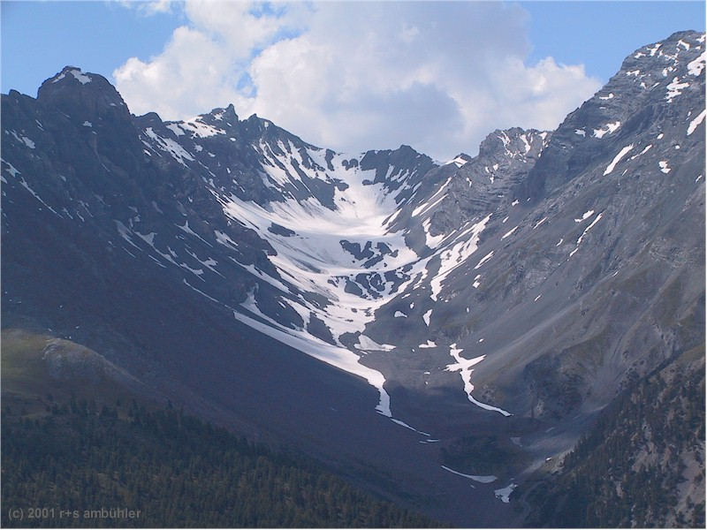
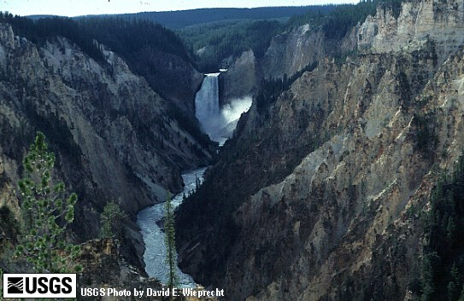
“V” shaped stream valley “U” shaped glacier modified valley

Streams
The most active and effective agent of erosion is running water. Falling rain runs across the surface of the land carrying sediment to lower areas. As the water runs across the surface it carves pathways that eventually grow into streams.
To a geologist a stream is any body of running water from the Nile to the trickle running down a driveway after a rain. As the stream grows it creates a river valley. The material that the stream flows over determines the shape of the river valley. Stream valleys fall into the following categories but do not necessarily develop along these categories.

- Degradational/young-actively eroding downward
  - Narrow “V” shaped valley
  - Straight channel
  - Waterfalls
  - Rapids
  - Fast flowing water
  - Steep gradient
  - Range of sediment size

- Balanced Stage/mature-balance between erosion and deposition; stream work is concentrated in lateral erosion
  - Meanders develop
  - Stream valley widens
  - Flood plain begins to develop both through lateral erosion and deposition of sediment
  - Gentle gradient
e. Well developed system of tributaries
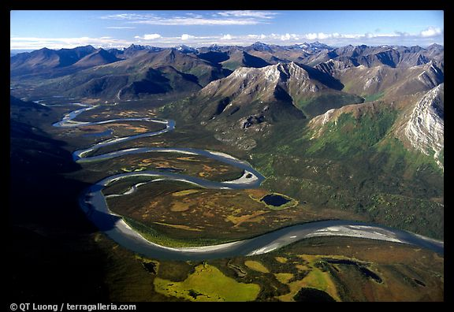
f. Beginnings of a delta

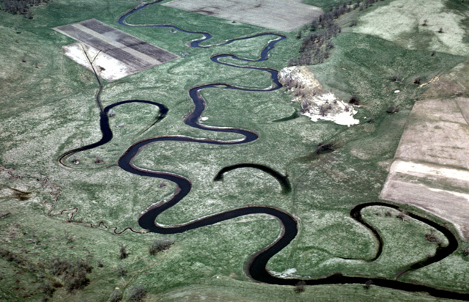

- Aggradational/old Stage-more deposition;
little erosion
  - Extensive floodplains
  - Deep meanders
  - Oxbow lakes
  - Gradient very close to flat
  - Well formed delta

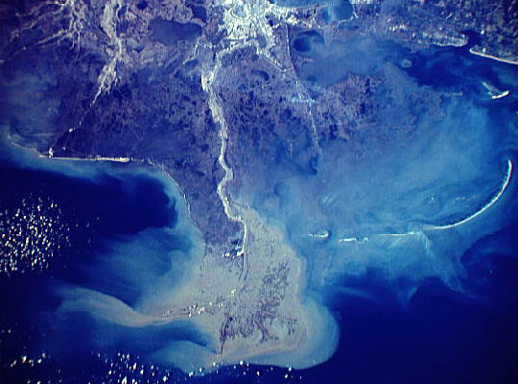
- Terminal Stage-stream has reached base level. Base level is the lowest a stream can reach
  - Extensive floodplains
  - Delta with distributaries

- Rejuvenated-land is uplifted beneath a balanced, aggradational, or terminal stage stream. The change in gradient increases the cutting force of the water and the stream begins to actively resume eroding downward but retains the characteristics of the previous stage

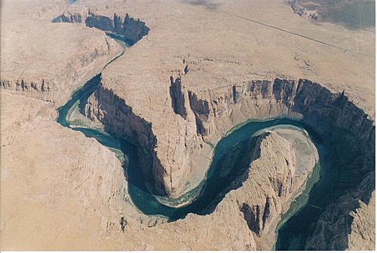

Two factors that determine the stream’s ability to do the work needed to erode and transport sediment are velocity and the discharge of the water. The gradient, shape of the streambed and the roughness of the bottom of the streambed govern the velocity. Gradient is the change in elevation of the streambed over distance. Boulders, ripples on the streambed and other obstacles in the streambed increase the friction that the water must overcome to flow downstream combine to slow the flow of the water.
Initially gradient determines the stream’s energy. Streams that flow in mountainous area have steep gradient, fast flowing water with the streambed littered with all sizes of sediment including large boulders. As the gradient becomes gentler, the velocity of the water slows. The streambed widens and becomes smoother reducing the friction. The wider streambed carries more water increasing the amount of discharge. Discharge is the amount of water that flows past a given point at any given time and is shown in m³/sec. Once the gradient begins to moderate, the discharge overcomes the gradient as the source of energy for the stream. Discharge can dramatically increase during flooding.

Beach Erosion and Deposition
Wave action produces erosional and depositional features along the shoreline. As the waves drag the bottom of the ocean floor as they begin to break, they pick up sand, shells and other types of sediment and carry it into shore. When the wave rolls up on the beach, it loses energy and deposits the sediment. The area where the sediment is deposited is called the swash zone because the water rolls up the beach when the wave breaks and back down the beach as the water returns to the ocean. This back and forth action is called swash. The sediments in the swash zone are more rounded and smoother because of this constant abrasion. In addition to the swash action the longshore current carries the sediment along the beach front until the current loses energy and drops the sediment.

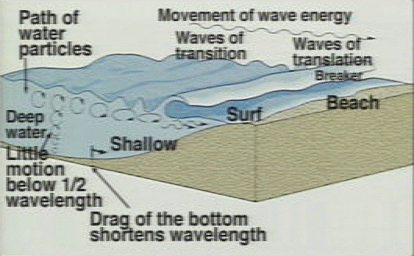
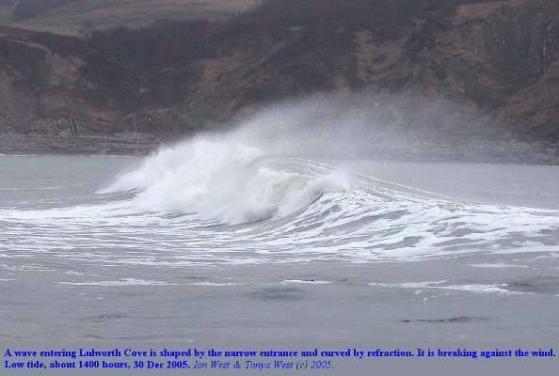

DEPOSITION
While erosion is considered a destructive force, deposition is a constructive force. It may not be building exactly where humans feel it should be but it is taking the products of weathering and erosion and building new landforms.
When the velocity of the stream decreases, the stream’s ability to carry sediment decreases. The stream begins to drop its load of sediment as it slows down. Deposition is the process of dropping sediment. The stream will drop the larger sediments first since it takes more energy to carry those particles. The stream then drops successively smaller particles until only the tiniest clay and silt size particles are held in suspension. Streams that have a very low gradient appear muddy because of the great amount of these particles.
The most obvious depositional feature of streams is the deltas formed when the stream enters a larger body of water. When the stream collides with the larger body of water it instantly loses speed and energy and drops its stream load.

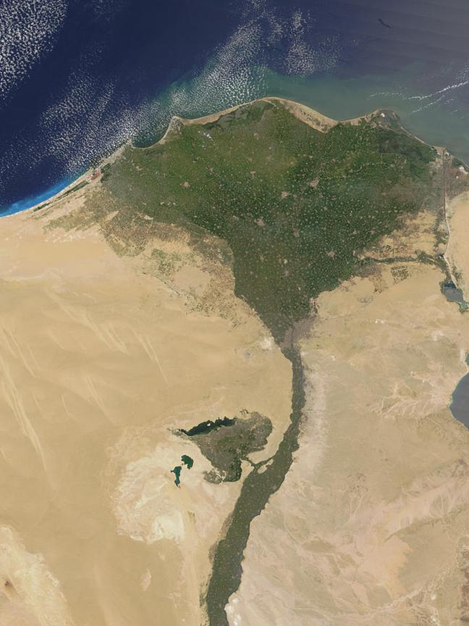

Nile Delta
Source of the term delta

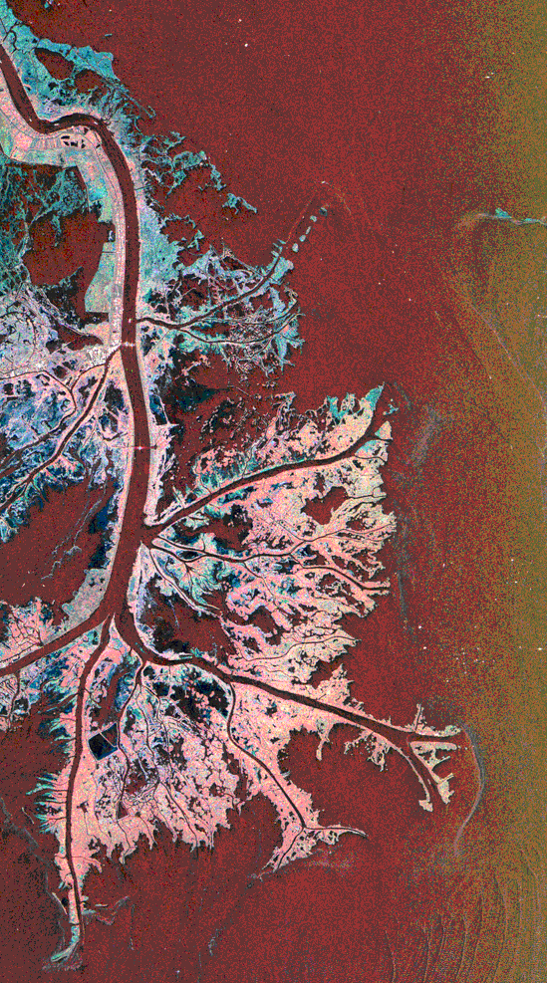

Mississippi delta
birdfoot delta

Another depositional feature of streams are point bars, which form on the inside of meanders. In order for the stream to flow smoothly around the bend of the meander, the water on the inside must slow down. Slowing down is loss of energy so the stream deposits its load forming a “beach” on the inside of the meander. Conversely, the water on the outside of the meander must speed up giving it more energy eroding the outside of the curve.
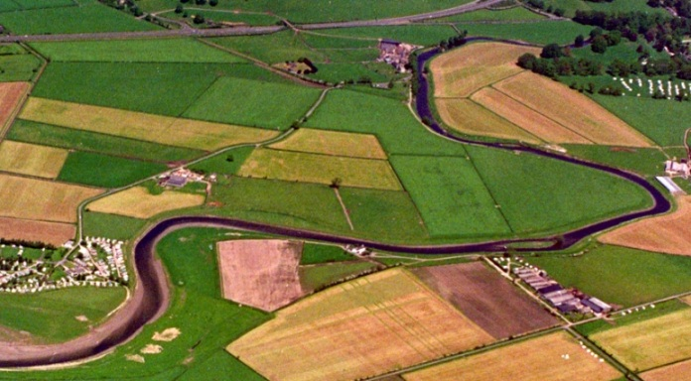

Point bar--→

Still another depositional feature of streams are the levees. Levees are formed when the stream floods. The stream has its channel suited for the fastest most efficient flow. The stream moves any object possible to conform the direction the stream is flowing. However, in a flood the volume of water exceeds the volume that the channel can hold. When this happens the water rises out of the normal channel to flow in the floodplain. Moving from the channel to the floodplain causes the water to slow down. Loss of speed means loss of energy, so the water deposits sediment along the edges of the channel. Each flood increases the height of the levee meaning that the next flood must rise even higher to breach the banks of the channel.

Wind
Since air is a fluid, it must follow the same natural rules as water. When wind looses energy, it deposits the sediments also. The most common depositional formation created by wind is sand dunes. Sand dunes are most commonly seen on the beaches of Texas but Texas also has extensive sand dunes in the Monahans Sandhill State Park (which by the way also has the world’s shortest oak forest).
Glaciers
Glaciers also create depositional landforms. The most outstanding of these features are the moraines. Moraines are formed as the glacier flows down the mountainside. The glacier’s weight grinds down through the layers of soil and rock above the bedrock pushing piles of the material along the front and sides of the glaciers much like a bulldozer grading a road or building site. When the glacier melts, the piles of material are left behind just like the piles of material left by bulldozers.
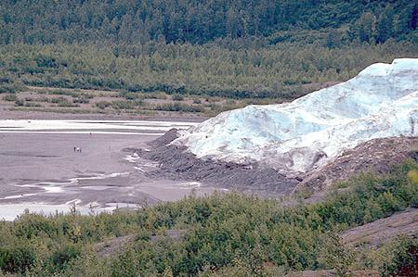

Terminal Moraine

Among other depositional features of glaciers include such landforms as erratics, drumlins and eskers. An erratic is a boulder that has absolutely no geological connection to any bedrock or formation in the local area. The boulder was captured by the glacier and transported to its location and deposited as the glacial ice melted. Drumlins are symmetrical mounds of till facing the direction that the glacier traveled. Eskers are snakelike ridges formed by a stream flowing beneath the glacier.
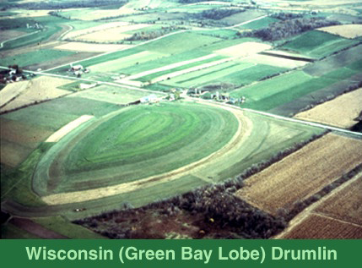

Drumlin

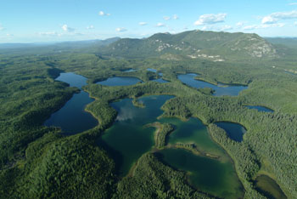

Eskers

While Texas does not have glacial striations or moraines or other features formed by the glaciers, there are features along the Texas and Louisiana Gulf Coast that can be attributed to the glaciers. The Mississippi River brought the Ice Age sand down to the Gulf of Mexico and depositing it in the delta. The currents distributed the sand along the Gulf Coast. This its the sand that eventually became the barrier island system of the Texas coast. The sea level rose and fell during the Ice Age forming chernier plain which is a series of ridges marking the various sea level changes. Chenier plains restrict the flow of water in and out of Sabine Lake on the Upper Gulf Coast.

Subsurface Erosion and Deposition

Erosion and deposition occur below the surface also. Rain water becomes acidic as it falls through the air and dissolves limestones and other water soluble rocks eventually forming caves. As the water drips through the cave it evaporates leaving mineral material behind forming stalactites and stalagmites.

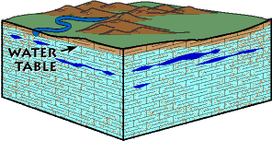
Rain falling through the atmosphere picks up
CO2 forming a weak acid. Acid dissolves
limestone. Limestone in the water table
begins to dissolve.
The slightly acidic water continues to
flow through the aquifer
enlarging the cavities in the limestone

Water table drops leaving cavities in the rock.
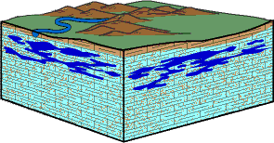
If these cavities have an opening they are
caves.

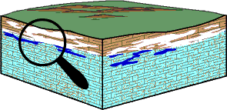

Water table drops leaving cavities in the rock.
If these cavities have an opening they are
caves.

Solution of limestone continues as the roofs of the cavities collapse leaving sinkholes.
An area filled with numerous hollows, caves and sinkholes is called Karst topography.
In the U.S. Karst topographical areas contain 25% of available groundwater

Karst topography
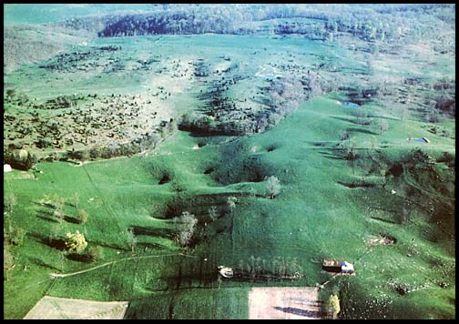
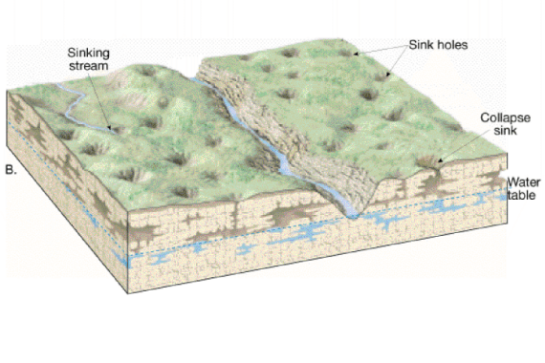

EROSION/DEPOSITION ACTIVITIES
Introduction to stream tables
Stream tables will be used for the following activities. Stream tables are models used to observe and experience the work of water, work that takes long periods of time that cannot be observed in one lifetime.

Materials
- Stream table tray-many types of containers can be used
  - Official budget stream table available through a science supply
  - Dish tubs from the dollar store
  - Baking pans
  - Paint trays designed to be used with rollers.
- Water supply
  - Drinking water bottles to soda bottles for water supply OR plastic cups with coffee stirrers
  - Plastic gallon containers for collection and reuse of water
  - Aquarium tubing to carry water to and from soil/sand
  - Tubs to catch water as students fill water source bottles.
3. Sand/Soil mixture
  - Diatomaceous earth is the best, however, it has a high concentration of silica, inhaling DE could possibly lead to silicosis. The diatomaceous earth that would be used is the same material used in swimming pool filter. Since there is the absolutely extreme outside possibility of developing silicosis, many school districts do not allow diatomaceous earth to be used in labs. Remember this is the same material used in swimming pool filters and most people never read the warning on the side of the box just ask a pool man.
  - Playground sand-easy to obtain. The disadvantage is that sand alone doesn’t
hold formations very long. DE helps hold the formations long enough for the students to watch the stream develop.
4. Mixtures-Sand, clay and gravel
i 80% sand for body
ii. 15% clay-for silt size particles
iii. Various sizes of gravel from moderate to aquarium size
Stream Table Hints
- Stream tables can be messy. If possible work outside.
- Preparing your classroom
a. Cover desks with butcher paper
b. Have broom, mop, mop bucket, dust pans and extra garbage cans available for cleanup. Extra packages of paper towels are also necessary for clean up.
c. Set work sites away from computers or other classroom equipment that could be damaged by water or sand.
Making Water Source Containers
Drinking water bottles
- Materials
  - Tubing either hospital or aquarium
  - Use a hot screwdriver or ice pick to melt a hole at the bottom of the bottle.
  - Insert tubing and secure tubing with caulking or hot glue
  - Water flow can be controlled by adjusting the cap.
  - 8 or 10 oz. bottle and a 2 L. soda bottle
  - 8 or 10 oz bottle-normal flow
    - use a thin hot nail to melt 3 or 4 small holes near the bottom of the bottle
    - flow rate can be controlled by adjusting the lid or duct tape over the holes which can be lowered to let the water flow
  - 2L bottle-flooding
    - use a larger nail to burn 5 or 6 larger holes near the bottom of the bottle
    - again flow rate can be controlled by adjusting the lid or duct tape can be placed over the holes and removed allowing the water to flow
- Place a ruler or strip of wood across the corner of the stream table
- Put the bottle on the edge of the stream table and the wooden strip
- Open the bottle and let the water flow.

Styrofoam or Plastic cups
- Materials
  - Cup size doesn’t matter
  - 2 hole coffee stirrer or 1 hole coffee stirrer
  - pipe cleaner or piece of wire
- Procedure
  - Cut a notch in the edge of the cup
  - 2 hole coffee stirrer
    - insert the pipe cleaner into one side of the stirrer
    - bend the stirrer
    - dip the combination into a full glass of water and fill the empty side of the straw with water
- Fill the cup with water. If desired use food coloring to tint the water
- Set the cup on the surface of the sand.
- Place the filled coffee stirrer in the notch
- Water should begin flowing out and down the sand

Gradient vs flow
Gradient
Introduction
Time 1 class period
Materials
- Ramp
- Hot wheels car or pinewood derby car
- Protractor
Procedure
- Teacher asks students what will happen to the speed of the car when the angle of the ramp is changed.
- Car is placed on the ramp and released
- Lower the angle of the ramp
- Car is placed on the ramp and released
- Lower the angle of the ramp
- Place car on ramp and release
- Discuss class observations

Extensions
Added materials
- Stop watch
- Meter stick
Procedure
- Make a starting line and finish line on the ramp.
- Measure the distance. 1 meter is an excellent length
- Place the car on the starting line
- Start the stop watch when the car is released
- Stop the watch when the car crossed the finish line
- Calculate speed using
V=distance
time

Stream Gradient
Time 1 class period

Materials
- Stream table
- Sand/clay/gravel mixture
- Water source containers
- Water collection containers
- 3 supporting planks for gradient
- 1 support for water source
- Tubing
- Flags for identifying features
- Paper and pencil to record observations
- Clean up supplies
Procedure
- Fill the stream table about 1/3 full with the sand mixture
- Place 3 supporting boards under the stream table. These will be removed one at a time to change gradient.
- Set water support across one corner of the stream table
- Connect drain tubing
- Have students make flags for features that they will observe
- Students record observations and comparisons for each stage or teacher can assign different groups to each stage. Then have class collaborate on results.
Stage 1
Place 3 supporting boards under the stream table. This should be the highest level producing the most energy.
Stage 2
Remove 1 board. Flow should be slower
Stage 3
Remove 1 board. Flow should almost stop
Stage 4
Remove all boards. Stream table is flat on the table.

Results
As the gradient changes the water will slow down.
At stage 1 the water should flow swiftly and the channel should remain relatively straight while being cut downward quickly. This is the degradational or youthful stage of stream development. This stage will form a delta.
Stage 2 – The water slows down and should form meanders and delta. Point out areas of deposition on the inside of the meanders, cutting on the outside and the deposition pattern of the sediments as the water looses power.
Stage3- water flow is slow. Water will puddle and appear muddy. The larger gravel pieces will not be moved because of the lack of energy
Stage 4-no water flow

Extensions
- Compare speed of water at various elevations to the intro demo.
- Use maps that show elevation in some manner and have students identify which areas of the country produce which types of streams
- Have students collect pictures of streams and classify them as to stream age.
- Have students determine types of streams prevalent in your area. Have them give locations where deposition and erosion can be found along local streams

VOLUME
Time
1 day

Additional Materials
- 2 water sources with different volumes

Procedure
- Follow the same procedure as outlined in the gradient section. The teacher may specify the gradient to be used or assign different gradients to different groups. This will help students focus on testing one variable at a time.
- Students first review data from normal water flow collected previously or students may do normal water flow to establish a base line for comparison to increased volume.
- Students open the increased volume source and let it flow recording observations as the water flows.

Extensions
- Have students design flood control measures for their stream table and test those creations.
- Have students locate local areas that flood and develop flood control programs for the area.

GLACIAL EROSION
Time
1 day

Materials
- Stream table set up with previously eroded stream valley
- Freeze a sandwich container with a mixture of gravel, rocks and sand
- Aluminum foil

Procedure
- Prepare a “V” shaped valley on the stream table.
- Give each student group a slab of the prepared “glacier”
- Ask the students to show how glaciers can reshape a stream valley
- Slide the “glacier” down the river valley. Have the students record the results. Warn the students not to push the “glacier” all the way through the sediment.
- Give student groups aluminum foil
- Have them slide the “glacier” over the aluminum foil and record the results
Results
- The “glacier” should widen and reshape the valley. Students should also be able to see the grooves and moraines that glaciers form.
- The sediment laden “glacier” should produce striations on the aluminum foil much like a real glacier does on bedrock

MAKING A SEDIMENTATOR
A sedimentator is a closed sealed tube container water and sediment. Students can shake the sedimentator and watch as the sediments settle.

Materials
Gravel, Sand, Clay
Small rocks a bit larger than the gravel
Alum
Polycarbonate Tube Lamp Guard
11/2” PVC pipe end caps
Super Glue

Procedure
- Cut tube to the desired length
- Place a cap on one end of the tube.
- Secure the cap with super glue
- Pour gravel/sand/ clay mixture into tube
- Add water until the tube is almost full
- Place second cap on tube
- Allow structure to cure

Shake and watch the sediments fall!

READING EXTENSIONS-these books are listed in River Cutters from Lawrence Hall of Science

Books
Book of Planet Earth, Martyn Bromwell, 1992
Cadillac Desert: The American West and Its Disappearing Water, Marc Reisner,
1987
Chiseling the Earth: How Erosion Shapes the Land, R.V.Fodor, 1983
Dorling Kindersley Science Encyclopedia: The Earth, An Introduction to Physical Geology, Edward J. Tarbuck and Frederick Lutgens, 1993
Geography of the Earth, Susan Brooks, 1991
Grand Canyon: The Story Behind the Scenery, L. Greer Price, 1991
Historical Atlas of the World, Stephen J. Gould, Rodger Osborne, Donald Tarling
1996
The Pebble in My Pocket, A History of Our Earth, Meridith Hooper, Chris Coady,
1996
Weather, David Ellyard, 1995

Literature Connections
The Adventures of Huckleberry Finn, Mark Twain
Biography of a River: The Living Mississippi, Edith McCall
Danny Dunn and the Universal Glue, Jay Williams and Raymond Abrashkin
Drylongso, Virginia Hamilton
Minn of the Mississippi, Holling Clancy Holling
The Missing Gator of Gumbo Limbo: An Ecological Mystery, Jean C. George
Paddle to the Sea, Holling Clancy Holling
The River that gave Gifts, Margo Humphrey
Encounters with the Archdruid, John McPhee

Sources for Erosion: It’s Elementary Dear Teacher

Murck, Barbara W., and Brian J. Skinner. Geology Today: Understanding our Planet. 1st ed. New York, New York: John Wiley, 1999.
(Murck and Skinner 190-213)

Haggerty, Michelle M. Texas Parks & Wildlife.Master Naturalist Statewide Curriculum. College Station, Tx: Texas A & M University, 2003.
(Haggerty, TPWD 13-44)

Tarbuck, Edward J. and Frederick Lutgens. Earth An Introduction to Physical Geology. 7th ed. Upper Saddle River, New Jersey: Prentice-Hall, 2002.

Lutgens, Frederick K. and Edward J. Tarbuck. Foundations of Earth Science. 4th ed. Upper Saddle River, New Jersey: Pearson Prentice Hall, 2005.

Marshak, Stephen. Earth Portrait of a Planet. 1st ed. New York, New York: W. W. Norton & Company, Inc, 2001.

Dallmeyer, R. D. Physical Geology Laboratory Text and Manual,6th ed. Kendall/Hunt Publishing Co. 2000.

Tarbuck, Edward J., Frederick Lutgens and Kenneth Pinzke. Applications and Investigations in Earth Science. 5th ed. Upper Saddle River, New Jersey: Pearson Prentice Hall.2006.

Feather, Ralph, Susan Leach Snyder and Dale Hesser, Earth Science. 1st ed., Westerville, Ohio: Glencoe Publishing Co. 1995.

Sneider, Cary and Katherine Barrett, et al, River Cutters. 5th ed. Berkeley, California: Lawrence Hall of Science, 2003.

Montgomery, Carla, Environmental Geology . 7th ed. New York, New York, McGraw-Hill Higher Education, 2006

Anderson, John B. The Formation and Future of the Upper Texas Coast. College Station, Texas, Texas A&M University Press, 2007

Texas; Soils, Geology, Rocks, Fossils, Dinosaurs Workshop; Bamberger Ranch, Compiled by Margaret Bamberger selah@tstar.net

Online Resources for Teachers
Shoreline Info
NOAA/National Geophysical Data Center coastal programs
www.ngdc.noaa.gov (this will come up with a message saying this URL cannot be found, go to the bottom of the frame and click ngdc which will bring up the National Geophysical Data Center, then choose the category needed
Streams-great deal of information and pictures at this web site
http://water.usgs.gov
http://water.usgs.gov/waterwatch/ current state of flow for streams across the country.

Glaciers
http://tvl1.geo.uc.edu/ice/image/imageref.html

Soils
http://www.tx.state.nrcs.usda.gov/

http://websoilsurvey.ncrs.usda.gov.

Various activities

Mineral Information Institute
http://mii.org

Women in Mining

http://womeninmining.org

Texas Bureau of Economic Geology
http://www.beg.utexas.edu/
Select Teachers and Students-view units available from the BEG.
Suggested Units
Is Dirt Just Dirt?
Floods!
Aquifer in a tank
CO₂ Outreach

Images for this presentation were taken from Google Images.

